

School of Computing, Electronics and Mathematics

PRCO304

Final Stage Computing Project

2015/2016

BSc (Hons) Computing & Games Development

Daniel Bendell

10402435

Bayesian Probability Controlled Artificial Intelligence in a Traditional Turn Based Strategy Game

Supervisor: Serafim Rodrigues

Second marker: Dan Livingstone

Table of Contents

Abstract 5

1. Introduction 6

2. Background and objectives 6

3. Approach 7

3.1 Unity 7

3.2 Visual Studio & Resharper 8

3.3 Game Design Document 8

3.4 Illustrator 9

3.5 Blender 9

3.6 Competition Comparison 10

3.7 Platform 10

3.7.1 Mobile IOS & Android 10

3.7.2 Consoles Xbox & PlayStation 10

3.7.3 Web & PC 10

3.8 Bayesian Probability 11

3.9 Architecture 11

3.9.1 Characters 11

4. Project Management 13

4.1 Trello 13

4.2 Kanban 13

4.3 Source control 14

4.4 Project Plan 14

4.4.1 Initial Project Plan 15

4.4.2 Final Project Plan 16

5. Outcome 17

5.1 Development Objectives 17

5.2 Software Life Cycle 17

5.3 Game Design 19

5.3.1 Overview 19

5.3.2 Game Flow 19

5.3.3 Core mechanics 21

5.3.4 Bayesian Probability Adaptation 25

5.4 Modelling and User Interface 28

5.5 Database & API 29

6. Testing 29

7. Project Post-Mortem 30

8. Conclusion 31

References 32

Appendices 33

Abstract

This report outlines a game development project with great focus on the underlying Bayesian’s probability artificial intelligence system.

The report starts with a series of research and investigation papers all of which focus on the initial approach towards the project’s needs. The results from each research element are summarized to provide a better understanding of their outcomes. The resulting evidence explains the reasoning behind the technology, artificial intelligence system and processes used throughout the projects lifecycle. Further analysis of the project design is shown to allow the visualization of class structure.

The strict project management tools and work flows are discussed in greater detail, giving insight into successful management techniques used throughout the projects development. The initial and final project plan comparison shows how the management allowed the game to exceed in several different areas.

The steady development processes give an overview into the design, execution and maintaining of the games core mechanics. Descriptions of the games flow, main functionality and artificial intelligence system are provided to give reasoning to each element and how they brought the project together. The complex formulas are broken down to show how the game works around the programming challenges. An evaluation of the AI’s probability allocation, decision making and learning are given.

An overview of the games incremental and overall testing is assessed, summarizing the results. This is followed by the projects post-mortem, which indicates the areas of the project that have seen successes, whilst noting the stages that could have used different approaches or strategies.

# Introduction

With the forever growing popularity of computer based games, it is becoming essential to create unique, engaging and powerful artificial intelligence (AI) systems.

The aim of this project was to create a turn based strategy game that can be played against the computer in the form of AI.

This report presents the research, design and production of the turn based strategy game, with a high focus on the artificial intelligence, the main aim being a smart AI system that is able to assess and formulate a response to a range of different situations.

# Background and objectives

The initial plan for this project was a multiplayer real time strategy game, where two players would compete against one another. The players carefully select from a set of predefined characters, position them in any strategical arrangement, then taking turns to move the chosen characters around a fixed map or environment to out manoeuvre their opposition, with an end goal of defeating the opposition in tactical combat.

This initial project idea was carefully broken down into more detail in the form of a project initiation document (PID) and is available for reference in the appendices. After further discussions with the provided supervisor it soon became clear that this was a suitable project to undergo, however it lacked slightly in terms of a challenge. This new level of challenge was expressed to give the project something more exciting than the initial plan and would be a welcome adjustment to the proposed project.

After further discussion with the supervisor it was suggested that instead of making a game that focused on a player vs player environment that it shifted towards some form of artificial intelligence (AI). Creating a game that was playable verse the computer would require more complex coding methods and research into a number of different approaches to solve this new problem. Using AI in the project would introduce a new area of development to the author.

As this was the only additional suggestion made towards the proposed project as well as the PID being approved in its original state, it was clearly a sensible project to undergo with enough reach for a prosperous game.

After assessing the project objectives within the PID and comparing them to the Specific, Measurable, Achievable, Relevant, Time-bound (SMART) principle there was room for improvement. Although the vast majority of the objectives were specific, giving clear, precise goals and outcomes, it was believed that some of them (Objective 4, 5) could have been broken down further to give a greater understanding of the original objectives.

In terms of being measurable, all bar the last objective had been formulated to give a clear indication of being completed or not. As for the last objective it was more of a personal objective. Although the objective clearly states that it will be measured by the outcome of a fully functional game. The completion of said game could be very basic and not have challenged the developers programming ability, because of this its focus was altered to make it more applicable, emphasizing the need to create a fully functional game that introduces new and challenging elements to the developer.

Creating achievable objectives was very important as it would give a sense of accomplishment throughout the research and development of the project. The moral boost that comes with completing a task is very important in the development process. The entire project was broken down into incremental steps (available Trello link) and explained in more detail further in the report. Each one of the objectives has resources available to show that they were indeed achievable, some of which are resembled within the final project and more are available in the appendices.

Relevance is an area which could have been improved. Although the objectives are relevant in terms of the entire research and development process, they should have been more specific when writing objectives five and six. The objectives hold a heavy influence on the research part of the project. However point three is not as focused as it should be. This point targets the environment chosen to use when developing the project opposed to focusing on the project itself. It was a very important aspect of the entire project but does not express an overall objective for the final project.

Time-bound was an interesting element to consider as the overall project was broken down into a project plan which specifies the goals and time frames in which they were given. Although the project plan didn’t cover all of the objectives it did break it down into more reasonable tasks to be achieved throughout the research and development stages. Each one of the objectives had been accounted for within the plan and progress was documented through weekly highlight reports. These reports were a healthy reminder of the initial project plan and how each weeks work had fit in with the corresponding time frame.

# Approach

As the project and its initial ideas began to unfold it was clearly a sensible plan with enough scope for expansion if necessary. As stated in the background and objectives there were little changes to the original project. These changes were made to make the game more challenging to design, develop and test. Although the changes were not set in stone it was important to evaluate them as this would ensure a better overall project.

## 3.1 Unity

One of the first hurdles that needed to be overcome before the development started was to assess the different technologies available and how each one was going to benefit the development stages. To give a better understanding of the options, a research paper was completed in which several game engines were assessed to demonstrate their strengths, weaknesses, opportunities and treats (SWOT), refer to the game engine research in the appendices for more information. Not only did the research paper bring insight into which game engine was going to help develop a top quality project, it enlightened the areas of the project that could have proved to be more difficult than first anticipated. The end result of the paper highlighted Unity as the chosen game engine. Some of the deciding factors were the experience the developer had with the environment, the rapid development made possible with the built-in level design and the access to its own asset store. These are only some of the factors that played a part in the decision but deemed the most important. Knowing that the project needed to be developed swiftly, there was a massive need for external assets, mainly 3D models.

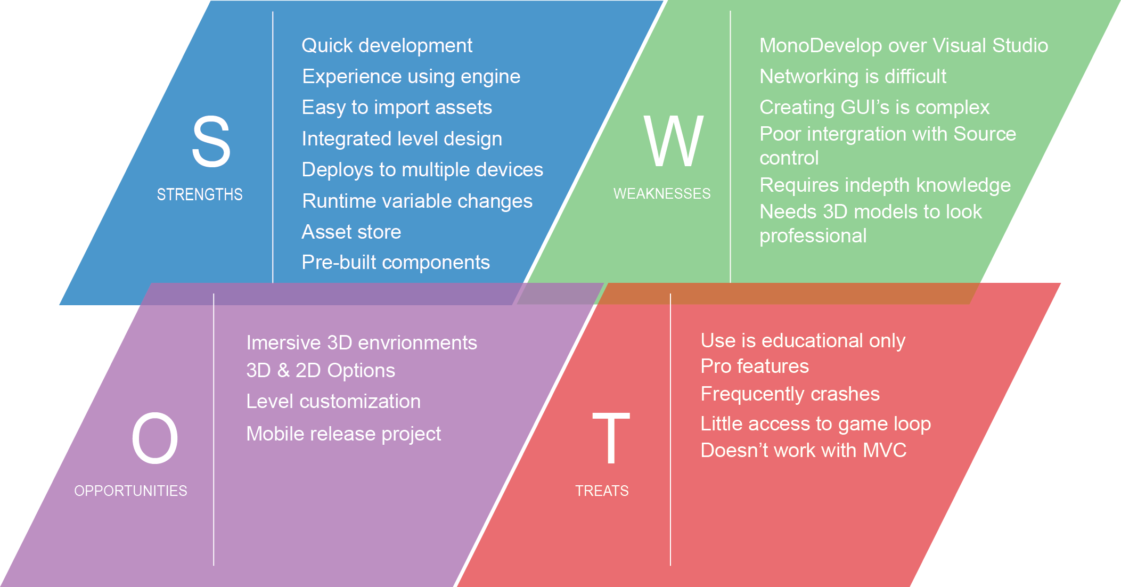

Using Unity allowed the developer to play to their strengths as a programmer. He was able to use C#, which is the programming language he is most comfortable coding in. There was less emphasis and pressure on level design as Unity has its own built-in level editor. Unity can be debugged extremely easily, giving the option to edit variables during runtime. Unity makes it effortless to deploy to multiple platforms, this means that if the direction of the project changed and moved towards another platform, it would require little change if any at all.

## 3.2 Visual Studio & Resharper

One of the main concerns with using Unity was the integrated development environment (IDE) Mono Develop. Although this may not strike many people as a real issue, it was believed that programming on a poor IDE could lead to sloppy coding. Luckily after only a small amount of research it became clear that Unity could be integrated with Microsoft Visual Studio. The Visual Studio plugin offers full syntactic support along with simple debugging options, everything needed to get the ball rolling. Another bonus of using Visual Studio was its additional plugin Resharper. Resharper is like a second pair of eyes for your code, it will ensure you code in a uniform format, keeping the variables consistent throughout the project and offering alternatives to certain coding approaches. For example using a LINQ statement instead of iterating through a list of items in a for loop.

These are very small enhancements for such a large project but the payoff can be immense when passing on a code base to another programmer or simply ensuring the code is clean.

## 3.3 Game Design Document

After deciding on a game engine to use, a game design document (GDD) was created and made available using the reports appendices. The aim of a GDD is to be a more in-depth, descriptive document, outlining the story, characters, level, gameplay, art, sound, music, user interface, game controls (*Game design document*, 2016). All of these sections are vital when developing a successful game and each area was carefully assessed before starting the development of the project. Traditionally as the development of a game grows so does the size, structure and information stored in the GDD, however creating a skeleton for this document was important before the development started. It added direction towards all of the important areas required. The GDD is a very visual document expressing ideas with a variety of different media, whether that be links to videos or music, pictures from existing games, concept art scanned in from a scrap book, they all play a key role in the document. With this mixture of resources it was easier to visualise the intended game.

When first deciding to create a GDD, the plan was to maintain it using a blog. This would allow the developer to reach out to an audience, granting them feedback on development and providing external advice to a very remote project. The decision went against this method as a thriving GDD seemed to be a better approach and resource.

After the creation of the GDD several different areas needed to be explored before starting any of the programming.

## 3.4 Illustrator

First consideration was which resource was going to be used to create any 2D and or 3D assets. At this point it was obvious both were needed but knowing whether or not there was a need to create them or find external resources was important.

2D illustrations were needed to act as the user interface (UI), without custom made UI the game ran the risk of not looking very professional. There was less emphasis on finding a piece of software to create the 2D illustrations therefore, the research did not go into the same depth as the game engine comparison. However the more popular software options were used to test which one was going to be most useful. The software tested consisted of Illustrator and Photoshop. Both were used to created basic assets, the comparison and thoughts can be found in the appendices under illustration tool test. The key elements that were trialled were the variety of options available and discovering which would be the quickest, easiest and best overall. It soon became apparent that using Illustrator was going to be the quickest way of creating simple assets and was the chosen application.

## 3.5 Blender

Continuing from the need for assets brought the research to 3D modelling. 3D modelling is extremely complex and takes years to master, however the need for creating models with beautiful texturing was not one of concern. It would be ideal for a full release as it increases the engagement but this was not the case. Knowing very little about 3D modelling made it important to find a tool that was going to be easy, yet efficient to use. This is where Blender proved to outshine. Free to use, with thousands of tutorials online to help with the basic requirements, it was the software used throughout the designing and modelling phase.

## 3.6 Platform

Upon deciding on all of the above, the need to focus the game towards a specific platform was still undecided. Due to selecting Unity as the desired game engine this opened up the options to target the project to several different platforms. Unity can easily build the application into Android, IOS, console (Xbox, PlayStation), web or standalone PC. Although it would be ideal to have the game available for each and every option it needed to be narrowed down.

### 3.6.1 Mobile IOS & Android

There has been a massive spike in popularity for mobile based applications and games. These are normally tailored towards people on the go, being intuitive to use, simple to maintain and engaging. Both IOS and Android are worthy candidates, however they might not produce the system power required to run the game. Knowing that Android alone has thousands of different devices all varying in size and specification was enough to sway the decision against the mobile platform.

### 3.6.2 Consoles Xbox & PlayStation

Next were the consoles. Both Xbox and PlayStation offer a lot more power than a mobile device and would comfortably be able to run any game developed through Unity. Despite their extended power the need to develop a game in such a way that is passes the criteria required by either Microsoft and or Sony proved problematic. Not only would it be mandatory to abide by their strict rules, the game would need to be finished to a professional standard and the time required to do so was not available.

### 3.6.3 Web & PC

Targeting the game towards the web would not have been a bad idea. It can be hosted on game sites, have a large audience ready and waiting and it would allow for instant exposure. However the need to play the game online is a large obstruction. Ideally the game will be accessible offline as it maximises the opportunity to be played. This brought around the final choice of a stand along PC game. Offering the options of online and offline play, being run on a powerful machine and with no need to meet the expectations of an external source. Building a standalone PC game was seen to be the best option for the proposed game.

## 3.7 Bayesian Probability

Lastly was the new focus of the project, the AI. This was going to be a very important part of the initial research as the developer had not completed any AI based programming before. It was key to understanding how different AI techniques could be used to really bring out the true potential of the game. After being provided with a little direction into which AI techniques could be appropriate, a research paper was completed outlining the potential AI techniques, refer to the AI research in the appendices. Knowing which AI system or systems were going to best benefit the games overall performance was vital. The end result showed an adaptation of the Bayesian probability technique, in which the AI will assess its given situation, calculate the probability of a series of different outcomes and execute an appropriate response. A paper better outlining the chosen technique is labelled Bayesian research in the appendices.

## 3.8 Architecture

### 3.8.1 Characters

The unified modelling language (UML) diagrams used to design the project are extremely difficult to properly visualise in their complete state due to the lack of space on paper. Because of this they have been broken down into smaller UML diagrams to better display their features. All diagrams shown in the report have enlarged replicas in the appendices under section UML diagrams.

The first UML is the central hub for all the characters, based around the characters controller. The characters controller loads all of the characters and tracks them within a list. The controller switches the characters at the end of their turn, removes them when they are dead, gets and sets the API data, along with a range of other functionality. The characters controller holds a list of character holders. The character holders are used to attach to the objects within the Unity editor as every element used in the Unity editor must extend from a Mono Behaviour. Wanting to keep the pure character model free from the game it has been wrapped in a holder. This allows for extended functionality without overloading the character class. The character holder contains the probability model used by the AI system as well as a Turn class which maintains the actions completed by every character.

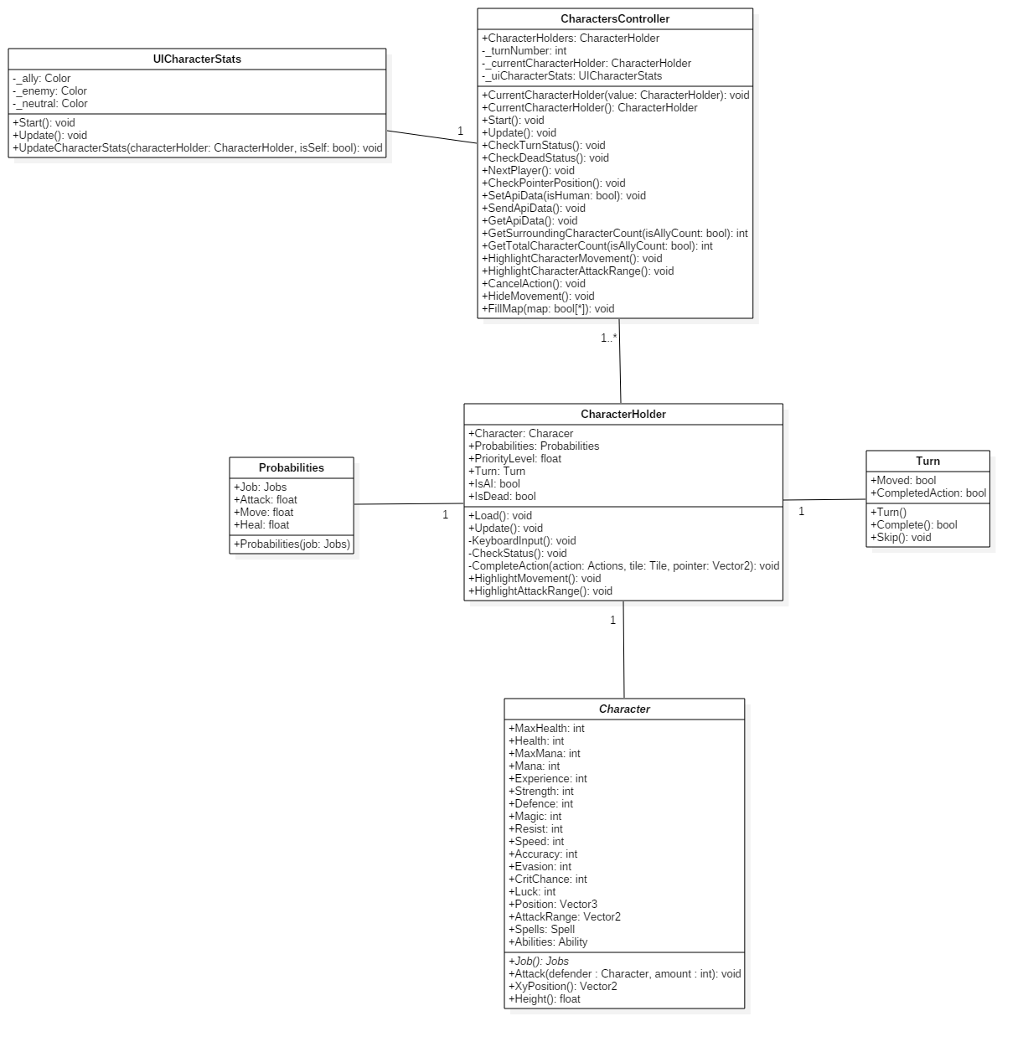

Next is the abstract character class. This stores all of the different stats for any given character as well as the Spell and Ability lists. These lists are also abstract and allow for a range of different classes to fill them. Below is an example of some of the intended spells and abilities for the game. The project contains many more but for the sake of the diagram it is clearer using a smaller pool of abstract classes.

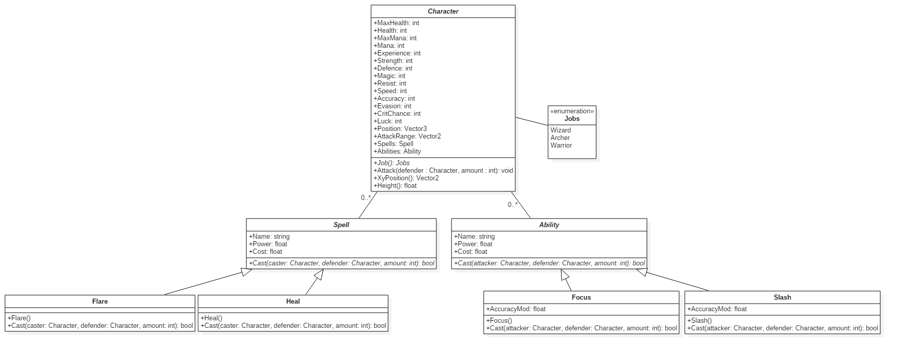

This is the breakdown of the different job options a character can have. Throughout the report these jobs are referred to as ‘Classes’ but it would become confusing to use that term here. Each job specifies the different stats given to them. These are what define their strengths and weaknesses, and can easily be adapted with the multiple constructors.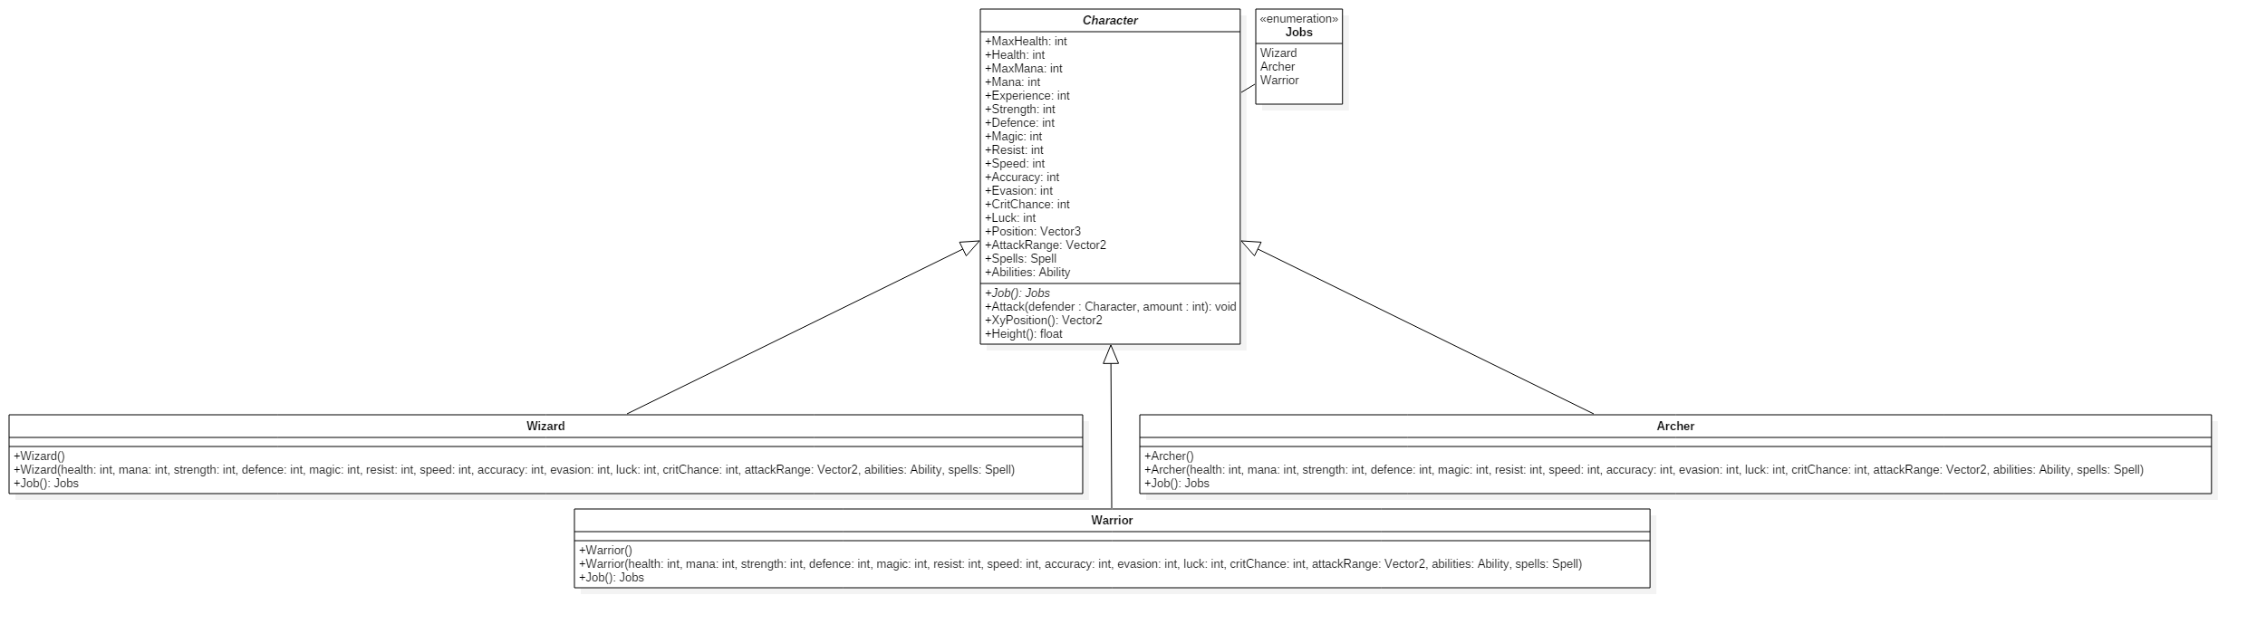

# Project Management

## 4.1 Trello

During the entire research and development stages the same project management tools were used. This mainly comprised of using the online software Trello. Trello is a simplistic management tool that enables the users to organise their workflow with the use of cards. Trello was used to maintain a record of all the different research and development milestones. Each milestone was broken down into maintainable deliverables and moved along the pipeline as it progressed.

## 4.2 Kanban

Kanban is an effective way of managing ones work by visually displaying all of the current work being completed and where it is positioned in the development process. Trello partnered very well with the Kanban method as cards can be manipulated around the screen very easily and quickly depict how well everything is going. As this project was being taken on by just one developer, it might not have been necessary to maintain a Kanban workflow but it proved to be beneficial in the long run. The Kanban board used, only contained a few different columns as the development process was in need for a quick turnaround on elements. These columns consisted of a backlog or to-do list, a developing stage, testing and complete. The backlog contained all the work needed for a minimal viable product (MVP), at any time a card from the backlog could be brought into the developing column as long as the total number of cards currently in development didn’t exceed four. This is a very important aspect of the workflow, as it makes sure that not too much is being worked on at one given time, and that each card being completed is receiving the required attention. Once a card is seen to be finished it would pass on to the testing column. Here it could sit for some time but much like the developing column it had a limit. The limit for testing was a slightly larger sitting at eight different cards. This brought the focus of the Kanban board to the development but didn’t allow it to get clogged up in testing. The final column complete, consisted of every single card that passed through all the previous stages. This worked as a reference to the work completed and nothing more.

## 4.3 Source control

To manage the code base, assets and documentation Git was used. Whenever a card or several cards moved across the Kanban board the work would be committed across to the Git repository. This served as a backup to all the work and enabled the project to be cloned onto any computer making it effortless to work anywhere and everywhere. Git also allowed for a review of progression, looking through all the commits and what they included showed how much work was done at each stage. After reviewing the process used for Git it could have benefited from some improvement. A system to tag each Trello card and commit would have been extremely useful as a back reference. Also following the Git flow method would have been useful but not deemed as a priority, as the project was maintained by an individual without the need to keep track of release, patches and or testing branches. If the project was to be moved into a team environment this would be put into place to ensure the Git history, branches and releases are all maintained correctly.

## 4.4 Project Plan

Taken directly from the PID the initial project plan clearly states the different levels of research and development, providing each one with a time frame and outcome. The project plan was very vague in terms of deliverables, proved difficult to follow, but clearly showed the different stages which needed to be completed.

Even though the project was kept to a strict management plan, with several techniques in place to ensure progression, there were expected changes when comparing the initial plan to the final outcomes and timeframes.

4.4.1 Initial Project Plan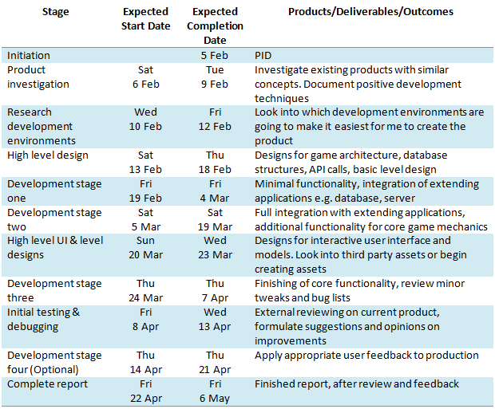

### 4.4.2 Final Project Plan

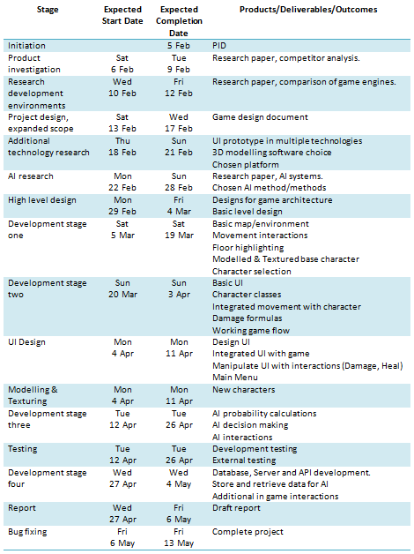

After comparing the two tables it is obvious that the initial plan was far too vague but this can only be expected seeing as it was completed before the project started. The final plan shows a higher level of detail specifying the direct outcomes for each stage. Some of the stages were able to be run at the same time due to the project management being extremely strict and allowing for constant progression. A vast amount of the time given to the project was taken up in research, although this might have stunted the development, it played such an important role within the overall project that the time given was completely justified. Without the extended research time, elements within the project could have suffered. The times and dates given for the final plan are a rough estimate but a clear representation of the time allocated to each stage.

# Outcome

## 5.1 Development Objectives

The development objectives from the GDD are as follows.

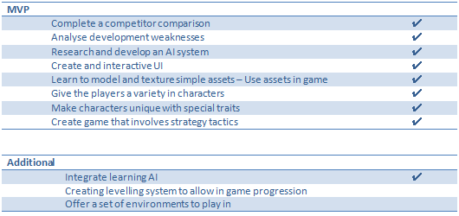

The table above clearly depicts the intended goals in terms of development and whether or not they were achieved. Not only were the primary goals reached, one of the possible extras has been completed.

## 5.2 Software Life Cycle

The software life cycle diagram below helps visualises the approach taken during the projects development. It also represents the life span for each and every Kanban card as it passed through the board and its varying columns.

Using the simple life cycle ensured that all the work being completed was done in a professional manor. This method made sure that everything being labelled as complete was going through all the necessary stages that help reduce errors and maximise on its implementation.

## 

Not following this life cycle could have led to elements being marked as complete, yet they hadn’t been tested or they were not designed properly, causing issues with the existing code base. When features received a complete status, the maintenance needed to keep the feature working with the growing project was much less than first anticipated. This is due to the way each feature was broken down and evaluated prior to any code being written for its implementation.

## 5.3 Game Design

### 5.3.1 Overview

The title “Final Adventure” was the result of this project, in which one player will compete against the created AI system. The goal of the game is to strategically move your chosen characters around a ten by ten map forcing your opponent into difficult to fight scenarios. The player will carefully select five characters of either different classes or the same and place them into starting positions. Each class type boasts advantages and disadvantages within the battlefield, so selecting a worthy combination is the first step to victory. As stated previously the player manoeuvres their characters around the map and is permitted to execute one action per turn. This may be a simple attack or a more complex ability or spell. Once a character’s health points (HP) have been reduced to zero they are removed from the game giving the advantage over to the opposition. The game will end once the player or the AI has run out of characters.

A lot like Chess the game focuses on a simple terrain, yet the understanding of each different character and their varying strengths in battle is what brings victory to a player.

### 5.3.2 Game Flow

Upon loading the game the player is presented with the main menu. There is not much in terms of options however they are able to continue towards the game or they are able to familiarise themselves with the controls and aims of the game before starting.



Once the game has begun the player will be navigated towards the character select scene. This is where the player is able to explore the different types of character classes ranging from Wizard to Warrior. This scene displays the given stats for each class e.g. strength, defence, health and more, as well as their available Abilities and or Spells. Understanding how these stats effect the gameplay are important, however it is also something that the player will need to experience in the game to fully understand. The player is also able to read an overview of spells and abilities available to give them more of an insight into the class choices.



Once the player has selected their five characters and placed them within the designated positions, the game will begin. Starting with the player they will be given the option to move each one of their characters in turn as well as the option to complete an action. Once a characters has moved and completed an action their turn is over, however if they choose not to move or not to complete an action they are able to wait. This will skip their turn and move on to the next character. The back and forth moves between the player and AI will continue until a victor has emerged. The game will then return to the main menu allowing for another go.



### 5.3.3 Core mechanics

#### 5.3.3.1 Selecting a team of characters

This is the first interaction for the player, increasing the need for it to be totally immersive. This scene includes a lot of animating between actions e.g. spinning the carousel of character types and moving the characters into position. These subtle actions are enough to draw in the players attention getting them hooked as soon as possible. This core mechanic allows the user to explore the characters for the first time, granting them additional knowledge of the overall look and feel. Using the left and right arrow keys the user rotates the carousel displaying either the next or previous character. Each character in the carousel can be rotated on its Z axis with the D key rotating them right and the A key rotating them left. This simple feature allows the user to better familiarise themselves with the character models to avoid confusion once the game has started. Finally the player is able to use the up and down arrow keys to move through the menu. The menu does not offer much but it does allow for the current character to be selected and placed into position and displays additional information on the current character. This additional information better explains their strengths, weaknesses plus their abilities and spells.

#### 5.3.3.2 Moving the pointer

Once the game begins the player is able to start their first move. As long as the player is in control they are able to explore the map and investigate the random opposition. To do this the player can use the in-game pointer. Resembled as a purple tinted square, this indicates where the current game focus is. Moving the pointer around the map will show both ally and enemy information e.g. Health, Mana, Class. The pointer is controlled using the W, A, S and D keys, moving it up, left, down and right. When the pointer is manipulated around the map the current active character will rotate to face its direction. This was a simple, yet effective minor mechanic that helps bring the game alive. The pointer is used to aid the selection of movement and character selection when completing an action.

#### 5.3.3.3 Using the UI

The UI has been created so it is extremely simplistic yet intuitive to use. The majority of the UI throughout the game uses the same scrolling menu on the side of the screen. The menus are created dynamically from a list of options. This has been done so it can easily be altered for each character as they all have different options. The up and down arrows are used to cycle through the menu options while the return key (carriage return) is used to select an option within the menu. The menus only ever show a maximum of four items at one given time, so by cycling down the items the menu scrolls down to reveal the entirety of the list. As the player is only able to complete one movement and one action per turn, each item in the menu can be disabled to visually show that the action has been completed. The currently selected item is also highlighted in a light blue and is animated to stretch out beyond the alternate options.

These menus use a method of main and sub menus to traverse through the cascading options e.g. selecting the ‘Spells’ menu item will hide the main menu, and reveal the sub menu containing the available spells. When in a sub menu or while finishing an action the player can press the right shift key to return to the previous menu.

#### 5.3.3.4 Moving characters

To move the character during their turn the player must first select ‘Move’ from the menu. Once selected the floor will highlight with the available tiles to move to, these tiles are highlighted in a red tint. Each character has a speed stat which determines how many tiles they are able to travel each turn. The player may decide to move the character to any one of the surrounding tiles assuming that it is within their speed limit and it is not taken by another character. The user is able to decide which tile they wish to move to using the game pointer mentioned previously.

When an appropriate tile is selected using the enter key (carriage return), the game will use the A star path finding algorithm to find the best route to the chosen destination. This algorithm returns a list of coordinates that navigate from start to finish. The game then moves the character from tile to tile whilst rotating them to face the correct direction.

#### 5.3.3.5 Completing an action

Much like moving the character, to complete an action the player must use the menu and sub menus to narrow down the options to just one. The actions have been broken down into more defined sections explaining their purpose in a little more detail. However as an overview, the actions are used to bring the game state in favour of the characters team. Generally this is in terms of an offensive action, tailored to bringing down the HP of the opposition.

**Attack**

Every class has access to the ‘Attack’ action as it is the fundamental element of damaging the opposition. An attack has no prerequisites bar that the character has more than one health point. Even though every class can attack an opposition they all have varying attack ranges. The attack range has been used to bring another level of diversity towards the different classes. Traditionally the attack range is one, meaning the characters have to be next to each other. However an example of a more complex attacking action is the Archer. As the Archer’s role includes using a bow and arrow, they are not able to attack characters within a close proximity, but are able to attack further than any other class. Knowing that every class type can attack is not enough, as attacking is not always the best option, as it is based on the characters strength statistic, meaning some classes are better at attacking than others.

**Spells & Abilities**

Spells and Abilities are more tailored towards the given class and not necessarily always offensive. Most characters have access to the ‘Heal Spell’ which simply heals a targeted character but the heal amount is based on the classes magic statistic. This brings another level of strategy to picking the perfect team composition. It means that a strong team doesn’t rely on a set of offensive character choices, but requires a combination of offensive and defensive. There are a range of other damaging spells available for use and have elegant partial effects to really bring them to life.

‘Abilities’ are similar to Spells however they are aimed towards manipulating statistics and damaging the foe. E.g. boosting accuracy to ensure the attack hits its target, or charging up power to unload a devastating attack but with reduced chance of success than a normal attack.

Both Spells and Abilities consume Mana when cast, meaning they are to be used situationally opposed to every turn. This again brings more strategic thinking towards each and every turn, getting the user to think about every action and how it is going to affect them in future turns.

**Wait**

Waiting, is the last option the player has for each characters turn. This will end their turn and move on to the next character. Waiting is used when a character wishes to attack an enemy yet stay in the same position. Or run away from the danger and not complete an action.

#### 5.3.3.6 Statistical formulas (Damage, Abilities, Hit/Miss, Critical hit)

Every action available in the game except waiting needed a tailor made formula to calculate the changes in values. This could be calculating the damage of an attack or the amount of health received from healing. A lot of these formulas are similar in structure but have been manipulated to produce the required outcomes. Here is the formula used to work out the physical damage produced for a normal attack.

D = ((SV / 250) * (SV / DV) * B + 2) * Mod

D = Damage

SV = Attackers Strength Value

DV = Defenders Defence Value

B = Base Damage Value

Mod = Additional Modifiers

This formula was adapted from the damage formula used in the popular game Pokemon (Bulbapedia, 2016). They are very similar in structure with minor changes tailored towards the project’s needs. The Spell and Ability formulas have been altered a lot more however, but this gives a good representation of how they were constructed.

This formula allows the damage to scale on several different aspects. The damage is scaled based on the class’s strength statistic. Traditionally the Warrior type class has boosted strength stats as they are the head of a fight, opposed to a Wizard who should keep their distance. Secondly is the base Damage value. In a normal attack action, the characters strength statistic is used, however this is changed for certain abilities like the Focus or Slash ability. Lastly is the Modifier Value, which mainly consists of the critical Hit chance. This is where the characters critical Hit value is used against a random number between zero and one hundred to determine if the hit should deliver twice the intended damage. The Modifier Value has been created to introduce weakness and advantage attacks, however this has not been included in the final product as there are not enough character classes available to create a healthy balance.

When a physical attack is being carried out the game also takes into consideration the chance of successfully hitting. The formula used to calculate each hit is not very complex when compared to working out damage values.

HC = HR * (AC / EV)

HC = Hit Chance

HR = Hit Rate

AC = Attackers Accuracy Value

EV = Defenders Evasion Value

Hit rate is a Class specific value, based on the class attack range. This means that Archers have a slightly smaller hit rate as they are able to attack from several tiles away, whereas a Warrior has a higher hit rate because their attack range is very small. This formula will result in a value relatively close or marginally above one. Any result over one is an automatic hit, where any hit chance under one will be compared to a random number between zero and one hundred. If the random number is higher than the hit chance multiplied by one hundred the attack will miss, otherwise it will hit.

All Spells are directly cast upon the chosen recipient therefore there is no need to calculate a hit chance for them.

### 5.3.4 Bayesian Probability Adaptation

#### 5.3.4.1 Summary

Bayesian probability is used to produce statistical probabilities for an unknown event based on information available either after or prior to the action. An adaptation of this method has been used to create the probability values for each human based character in terms of the chance to attack, move and heal. These are the three main options a player has when completing a turn so are the bread and butter for all the probability calculations.

#### 5.3.4.2 Calculating probabilities

At the start of every AI controlled characters turn, the game will run the current situation through the probability calculator. Every AI character will assess every human controlled character comparing stats like surrounding ally and opposition count, current health percentages and other variables. All of these and more have been used to carefully produce a set of values deemed viable as accurate predictions.

Ensuring that the probabilities for the three options attack, move and heal are calculated to benefit the AI’s decision making is crucial. Without this the AI might seem to make rash or in other terms stupid decisions going against the goal of an intelligent AI system.

There is no right way of correctly calculating the probability values but the formulas used have gone through several iterations to help make them more precise and meaningful.

**Attack Probability**

AP = ((ANT / ONT) * ((TPH / OTH) * (SV / DV))) * Mod

AP = Attack Probability

ANT = Allies Near Target

OPT = Opposition Near Target

TPH = Target Percent Health

OTH = Opposition Percent Health

SV = Strength Value

DV = Defence Value

Mod = Additional Modifiers

This formula was created whilst playing other TBS games, by carefully analysing the different components in a player’s decision. Some of the reasoning behind a players choice may not always be cognitively assessed, instead it may be just a habit from playing the game or similar TBS titles. This habit or instinct is comprised of so many different variables it is extremely difficult to focus them down into one formula. The above attack probability formula uses a variety of elements seen to be the most impactful in a player’s decision.

To breakdown the implemented attack probability falls into four main sections. Firstly is the character’s surrounding the target. Normally in warfare there is a great power in numbers and generally seen as a reason to attack or retreat. The number of allies is compared to the number of opposition characters but only if they are in movement and attacking the target. Any character out of range from the target is disregarded as they will not be able to directly impact the target in the given game situation.

Secondly is the remaining health of the target character verse the active AI character as a percent. These are compared to adjust the aggressiveness of the characters decision. Typically if a character is low on health they will become less aggressive and more defensive, this is also amplified when the targeting character has a greater health percentage.

Thirdly are the targets strength and the AI’s defence stats. These resemble the chances of the attack being an impactful action, swaying the decision to attack against a strong foe but enhancing it if they are weak.

Lastly is the modifier at the end of the formula, much like the attack damage calculation this acts as a final buffer towards the value. In the attack probability it is very simple, either increasing or decreasing the overall probability based on the targets Class type. Assuming classes such as a Warrior are going to be used more aggressively than a Wizard.

**Heal Probability**

HP = (DT (DT*JM, …, …)) * (OTH / ATH)

HP = Heal Probability

DT = Damage Taken

JM = Job Modifier

OTH = Opposition Total Health

ATH = Ally Total Health

The Heal probability is certainly the most interesting formula to be created for the game. It has a reoccurring calculation for each and every ally surrounding the current target that exponentially increases the chance of the heal action given the targets health lost as a percent and their class type.

To break this down a little further each human controlled character assesses their surrounding allies. The assessment is manipulated to increase the heal chance if one of the following situations is correct. An ally surrounding the target has very low health, the majority of the surrounding allies have lost a portion of their maximum health or the target assessing their allies are of class type that would deliver the greatest heal values e.g. a Wizard.

Even after this calculation there is the chance that the heal probability could be altered. The sum of all the surrounding AI characters health is compared to the sum of the surrounding human controlled characters and used to amplify the probability. This ensures that the heal action being completed couldn’t be used more effectively as an attack due to the health differences or vice versa.

**Movement** **Probability**

Probably the least important of the three options, but still an important element to take into account is the Movement probability. Calculating the movement probability of a character is by far the most difficult to achieve as it can be done either offensively, defensively, tactically or sporadically.

Due to the sheer amount of different possible uses of a movement it was not feasible to break it down into a formula. Instead it is based on the character’s current health points. The lower the health points the greater the chance of that character moving. This was done because the most important time a character might move is when they are retreating from battle and this is normally resembled by their health points.

#### 5.3.4.3 Assessing probabilities

At the end of the probability calculating each and every human controlled character will have a value ranging from zero to one for each of one of the three assessed options. Each one of the options is used to finalize the actions completed by the AI. The vast majority of the time, actions completed by the AI are rather predictable but this is a great sign. This shows the AI system is resulting in actions a human player would cognitively decide to do, oppose to something seen as random.

#### 5.3.4.3 Decision making

Ensuring the AI make intuitive decisions was one of the biggest back and fourths in terms of development. Even though the final outcome is actually rather simple it was important to test a variety of different methods to truly understand the underlining elements needed. The decision is broken down into two stages.

The first stage is finding a target on the opposite team. To do this the game goes through all the human controlled characters that are in attack range and applies weighted modifiers to the probabilities created in the previous step. The three weighted modifiers hold different values but starting with the most impactful is the amount of health missing from the target character, next is the chance that the character is going to heal another member of their team, lastly is their chance of attacking a fellow AI character. These weightings have been associated with the given attributes because they are seen to be the most impactful when deciding which character to target.

To give a better understanding of the approach the following has been produced.

* Targets missing health produces a value between zero and three
* Chance of the target healing another, produces a value between zero and two
* Chance of the target attacking another, unity produces a value between zero and one

The sum of the three values is assigned to each assessed target as a priority level.

The target with the highest priority level will be selected as a target. However there might not be any targets in attack range to evaluate in the first place. If this is true all of human controlled targets out of attack range are then assessed with the same criteria. It is important to assess the targets in attack range first as they are the only characters that can directly impact the AI unit.

This first step will always produce a target, even if their priority level is extremely low. The second step is for the AI unit to evaluate it’s in-range allies for healing. Nowhere near as complex as the targeting system, the healing target finder compares all the ally units within movement and heal range, then orders them descending by the percentage of health remaining. If the target at the top of the list has a health percent lower than the provided bound the AI will overwrite any human controlled target with its ally and prepare for healing. The bound used for comparison is altered based on the AI’s Class type e.g. increasing if the current AI is of a Wizard class type. This way the AI units are going to act more specifically to their given role.

If the AI does not need to heal one of its fellow team members, it will resume attacking the opposition target. At this point the game will pick a random offensive Spell or Ability from the list of available options linked to that class type. Assuming the current AI character has enough Mana to cast or complete the action they will do so, otherwise they will fall back to the standard attack option.

#### 5.3.4.4 Storing data

Part of the implemented AI system includes a level of learning, this enables the AI to adapt over time making its decisions less programmatic and more assessment based. In order for the AI to begin its learning, there needs to be a constant source of data being fed to it. This data is comprised of several different variables but the end result is taken from the human players and what they decided to do at the end of each given turn.

To store the required data a web server, application program interface (API) and database were created. The focus is not towards the web production of the product but more details can be found in the appendices in section Database & API documentation.

The API has two simple calls available. The one in regards to storing data requires each one of the following fields to be filled.

* Number of surrounding allies
* Number of surrounding AI
* Total number of ally characters
* Total number of AI characters
* Class type
* Target health percent
* Target Mana percent
* Movement (True/False)
* Action completed

The variables are taken at the beginning of the characters turn, and sent off to the database at the end of their turn.

#### 5.3.4.5 Learning

One of the more important areas of the AI is the learning system in place. Although it isn’t the most intricate in design or uses, it proves to be a vital aspect of the overall behaviour. At the beginning of the AI’s turn it will assess the opposition and retrieve all the corresponding data to their current in-game scenario. This will return all of the data entries matching their current situation and is used to aid the decision making process. The returned entrees are first grouped by the action value, and then ordered descending by the count of each group type. This will place the most common completed action at the top of the list. The game takes into account that the information gained from the database might not always be useful. If only a few entrees are returned it is ignored completely. This stops the AI from making decisions based on too little background knowledge. When enough data is returned and organised it plays a small part in making an overall decision, if this wasn’t the case the game could be played and manipulated in such a way to jeopardise the AI.

## 5.4 Modelling and User Interface

The user interface (UI) plays a strong part in the final project. Navigating the players through their battle options and displaying character statuses. It was important to make the UI very simple yet effective at displaying its meaning. Using a simplistic UI allowed for the focus to remain on the game environment, letting the player focus on the tactical play style over the interactive UI. All of the UI and its features have been explained in more detail within the GDD & Testing documents.

The modelling for the game was initially seen as a weakness towards the project. It was one of the major hurdles that needed to be overcome in order for the game to truly excel. After creating the simplistic UI the theme moved towards the models and their texturing. It soon became apparent that the models for the game didn’t need to be intricate in design or to a professional standard. Due to this all the models were designed by the developer giving them the chance to broaden their game development skill set.

The game does fall short in terms of professional UI and models but this was never the focus of the project. It certainly will be something that sees further adjustments as the project continues to grow in the future. For additional insight into the UI, modelling and other design features refer to the appendices.

## 5.5 Database & API

The database and API used for the game were introduced late into the development stages and therefore did not receive the same attention as the rest of the project. Using these features was an additional extra in terms of the MVP and only completed as the rest of the features were done. The structure of both database and API are explained in greater detail in the Database & API document. The need for these extra elements were to allow the AI to learn from existing data, storing the data from human controlled characters and using that information to fuel the AI’s actions.

One of the more important parts of this section was the use of RestSharp (*Simple REST and HTTP client for .NET*, no date). This is a very simple to use library, incorporated to access the REST calls available on the API. As time was of the essence and this feature needed to be completed as soon as possible the use of a library was very welcome. It meant that the development was completed a lot faster and there was no need to worry about going through all the minor testing phases if created by the developer.

# Testing

As stated previously in the project management section of the report, each and every element of the development process was tested before being labelled as complete. This meant that everything being placed into the game was double checked and reduced the chances of any problems as development continued.

During the end stages of development the testing focus moved towards the game as a whole opposed to individual aspects. This was a vital part of the entire project as it brought up several issues that could have been missed. As part of the overall testing phase a user test was completed. The user test consisted of someone using the game as intended, getting their feedback on its strengths, weaknesses, and any issues in the game flow or additional pointers to help as the development came to a close. The user testing report can be found in the appendices along with the series of test cases carried out on the game, see section labelled Game Testing. These test cases show each and every test carried out on the application to ensure that the proposed MVP objectives were met. The overall result of the testing phase was positive with the user pointing out some of the key features as the most intriguing. A summary of the completed tests have been created to give a better understanding of what was tested and how successful it was as a whole.

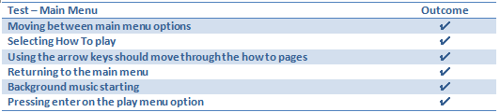

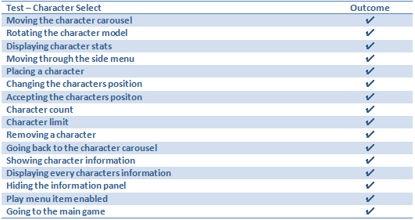

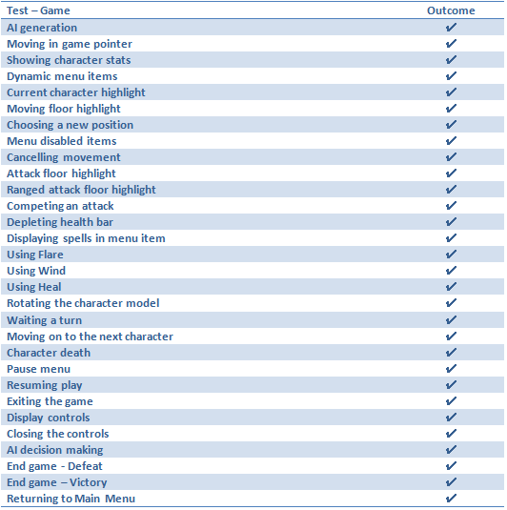

# Project Post-Mortem

As an overview of the entire project the results have been extremely promising. This being said there are several areas within the research, developing and testing phases that could have had some fine tuning or alternate approaches.

All of the initial objectives have been targeted and achieved, however the overall scale of the project could have been improved. The original plan for the game was much larger, offering a variety of options in terms of Maps, additional Spells, Abilities and Characters. This is purely down to the amount of time consumed by researching, understanding and development of the AI. Luckily the focus of the project swayed towards the AI from the very early stages, so the personal expectations of the entire game should have been lowered but the amount learnt and gained from taking the time to properly develop an AI system has been invaluable. It offered a much larger challenge in terms of development, and expresses skills that would not have been used.

The approach towards the project was strict in terms of how it was executed. Based on past experiences, knowing how to properly maintain ones development time is of the highest priority. This is why such a high emphasis was placed upon the project management. Being able to manage a project efficiently leads to a more robust and detailed project.

One of the biggest regrets in regards to the development stage was the structure of the project. Unity is known for being a difficult game engine to structure code and this has been one of the downfalls of this project. Additional time should have been allocated to better understand how to structure a project using the given technology. This would have led to more extractable, adaptable and maintainable code. If the project was to be started a fresh this would without a doubt be the area of the project that saw greater attention.

It has been mentioned that each element created was thoroughly tested before passing through the Kanban board. The time taken to do so was perhaps detrimental towards the project. This time was beneficial and professional in practice, but given the proved time scale for the entire project it could have been used to enhance other aspects of the overall project.

Another area which could have improved the project is using third party libraries. Only a minute amount of work was produced using third party libraries, all of which worked perfectly and sped up development time. Utilizing this more could have led to a larger project but the learning behind building a project from scratch is more important that the sheer size of it.

# Conclusion

Creating an intelligent AI system that fully immersed the user in interactive game play was without a doubt a challenge. The project successfully allows a user to compete against an AI controlled opposition, testing their wits, intelligence and tactics in warfare.

The completed game and AI offers a wide range of possible uses within a series of different game types instead of just the intended TBS game type. This adaptability really proves that the chosen techniques are one hundred percent viable for a production level game.

The project allowed for expansion on existing skills and the introduction of many more, the final product is seen as a humongous personal success. Not only did the project meet the initial objectives, it has allowed for the professional production of a stimulating game that will see continued development in the future and a public release.

# References

*Algorithms for realtime strategy wargame AI* (2016) Available at: http://stackoverflow.com/questions/3275174/algorithms-for-realtime-strategy-wargame-ai (Accessed: 7 March 2016).

*Android* (2014) Available at: https://www.android.com/intl/en_uk/ (Accessed: 6 February 2016).

*Bayesian probability* (2016) in *Wikipedia*. Available at: https://en.wikipedia.org/wiki/Bayesian_probability (Accessed: 1 March 2016).

Blender (2016) *Home of the blender project - free and open 3D creation software*. Available at: https://www.blender.org/ (Accessed: 24 February 2016).

*Bulbapedia, the community-driven Pokémon encyclopedia*. (2016) Available at: http://bulbapedia.bulbagarden.net/wiki/Damage (Accessed: 17 February 2016).

*Complex game AI for turn-based strategy games* (2016) Available at: http://gamedev.stackexchange.com/questions/21519/complex-game-ai-for-turn-based-strategy-games (Accessed: 7 March 2016).

*Game design document* (2016) in *Wikipedia*. Available at: https://en.wikipedia.org/wiki/Game_design_document (Accessed: 8 February 2016).

Game Theory Online (2013) *GTO-6-05: Bayesian games: Another example*. Available at: https://www.youtube.com/watch?v=-aeRHk55hmo (Accessed: 1 March 2016).

GitHub (2016) *Build software better, together*. Available at: https://github.com/ (Accessed: 15 February 2016).

Illustrator (2016) *Create beautiful vector art*. Available at: http://www.adobe.com/uk/products/illustrator.html (Accessed: 21 February 2016).

*Introduction to AI Techniques* (2009) Available at: http://web.mit.edu/sp.268/www/gamesearch.pdf (Accessed: 7 March 2016).

IOS Apple (2016) *Apple (United Kingdom)*. Available at: http://www.apple.com/uk/ (Accessed: 6 February 2016).

*Kanban* (2016) in *Wikipedia*. Available at: https://en.wikipedia.org/wiki/Kanban (Accessed: 15 February 2016).

Microsoft (2016a) *Games and entertainment on all your devices*. Available at: http://www.xbox.com/en-gb/ (Accessed: 7 February 2016).

Microsoft (2016b) *Microsoft developer tools*. Available at: https://www.visualstudio.com/ (Accessed: 7 February 2016).

*Minimax* (2016) in *Wikipedia*. Available at: https://en.wikipedia.org/wiki/Minimax (Accessed: 1 March 2016).

*Minimax search* (no date) Available at: http://intelligence.worldofcomputing.net/ai-search/minimax-search.html#.VznmnvkrKUk (Accessed: 1 March 2016).

*Minimax search and alpha-beta pruning* (no date) Available at: https://www.cs.cornell.edu/courses/cs312/2002sp/lectures/rec21.htm (Accessed: 1 March 2016).

Playstation (2016) Playstation. Available at: https://www.playstation.com/en-gb/ (Accessed: 7 February 2016).

Resharper (2000) *ReSharper*. Available at: https://www.jetbrains.com/resharper/ (Accessed: 7 February 2016).

*Simple REST and HTTP client for .NET* (no date) Restsharp. Available at: http://restsharp.org/ (Accessed: 6 May 2016).

*Techniques for an AI for a highly cramped turn-based tactics game* (2016) Available at: http://gamedev.stackexchange.com/questions/72230/techniques-for-an-ai-for-a-highly-cramped-turn-based-tactics-game (Accessed: 1 March 2016).

*Trello* (2016) Available at: https://trello.com/ (Accessed: 3 March 2016).

Unity. (2016) *Unity - game engine*. Available at: https://unity3d.com/ (Accessed: 4 March 2016).

# Appendices

## List of items

User Guide

PID

Game Engine Comparison

GGD – Game Design Document

Illustration Tool Test

Artificial intelligence research

Bayesian Probability research

UML & Flow Diagrams

Database & API Structure

Game Testing

User Testing

User Guide

# Setting up the Game

The set up for the game is very simple. As long as the build folder is in the same directory as the supporting exe the game will run.

In the example below you can see the ‘TestBuild_Data’ folder is available for the TestBuild.exe.

The name for the submitted exe will vary.

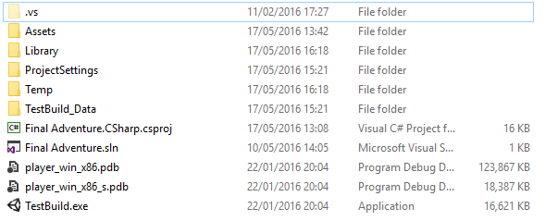

# Objective

Manipulate your selected characters around the 10 by 10 map, utilizing their abilities and spells to eliminate your AI operated opposition.

Once all of the opposition or the entire player controlled characters have been removed from the map (Health points <= 0) the team with the remaining characters wins.

# How to Play

1. Select your five characters and place them within the starting positions. (Characters can be of the same type, or varying)
2. Each character has strengths and weaknesses, keep note of them.
3. Move each of your characters around the map and complete an action
4. Completing an action can consist of an Attack, Spell, Ability or Waiting.
5. For every action a target must be selected.
6. Most actions are offensive and will cause the targeted characters health points to deplete
7. When a characters health reaches zero, they are removed from the game.
8. Defensive spells can be used to aid allies (Restore health points)
9. Once all of your characters have completed their turn, the AI will begin to operate.
10. 3-9 will be repeated until a team has no more characters to control.
11. The game will end and the victor will arise.

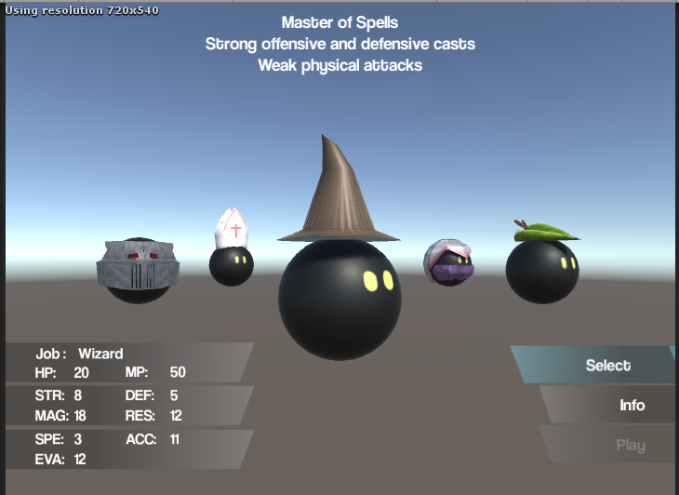

**Controls**

Left & Right arrows – Move carousel

A & D – Rotate character

Up & Down arrows – Move menu item

Enter – Select Menu item

**Selecting Characters**

1 - Strengths and weaknesses

2 - Character stats

3 – Menu  
Select character  
Additional information (Spells & Abilities)   
Play (When 5 characters have been selected)

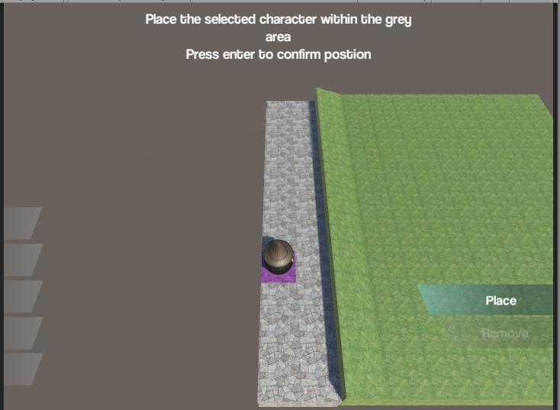

**Placing Characters**

1 - Available positions

2 - Current position

3 - Number of placed characters

4 – Menu  
Place Character  
Remove Character (When another character is in current position)

**Controls**

W, A, S, D – Move current position

Enter – Select Position or Remove

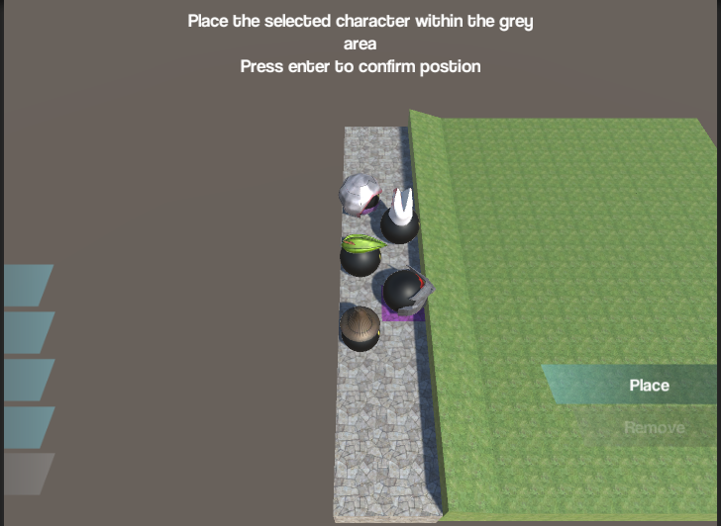

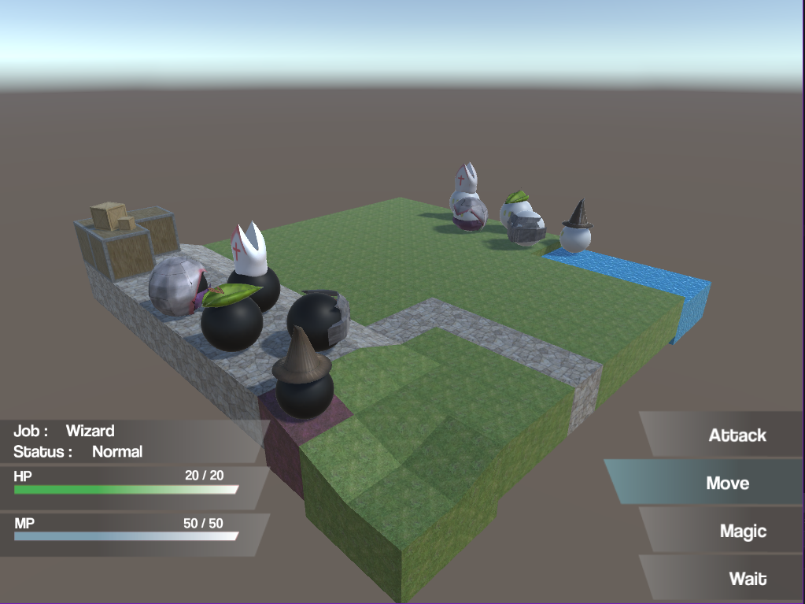

**Controls**

W, A, S, D – Move pointer

Up & Down arrows – Move menu item

Enter – Select menu item

**Map Layout**

1 - Player characters

2 - AI characters

3 - Pointer

4 - Selected character stats

5 - Menu

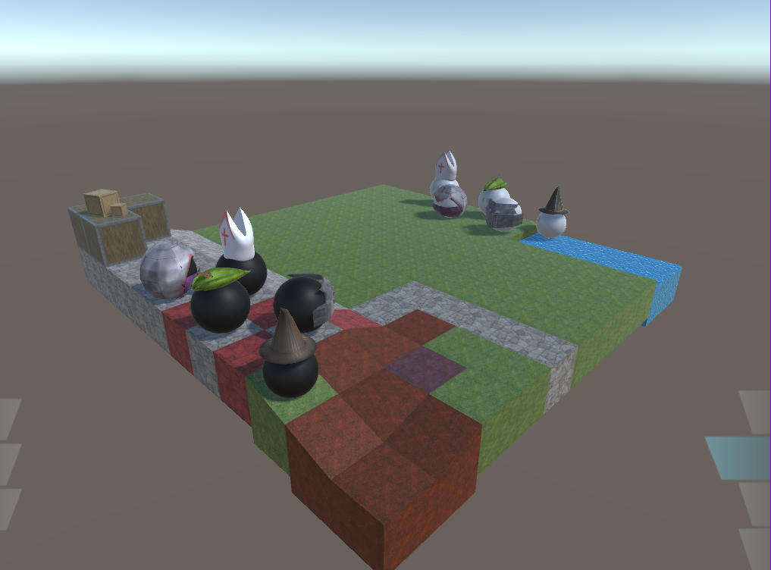

**Move Action**

1 – Available spaces to move to

2 – Pointer

**Controls**

W, A, S, D – Move pointer

Enter – Select new position

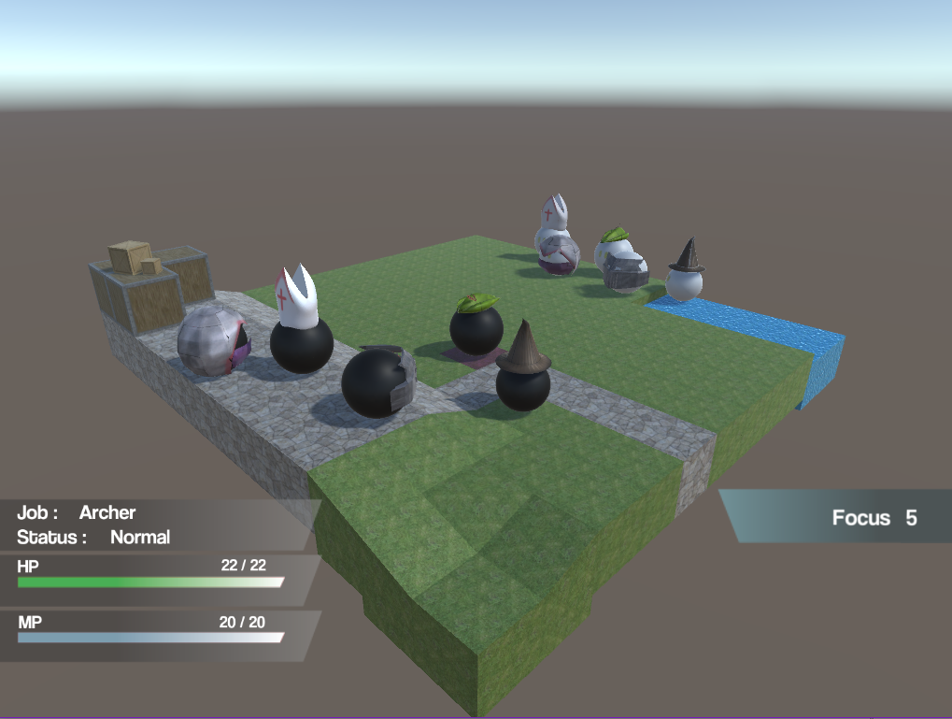

**Controls**

Enter – Select chosen ability

Right shift – Previous menu

**Ability Select**

1 – Ability name

2 – Ability Cost

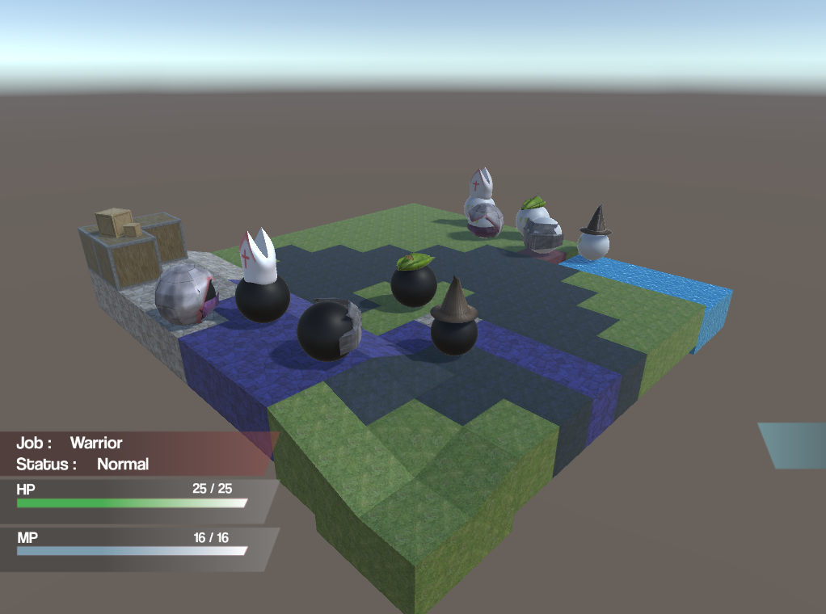

**Controls**

Enter – Select target

W, A, S, D – Move pointer

Right shift – Cancel Action

**Using an Ability**

1 – Ability cast range

2 – Target

3 – Target stats

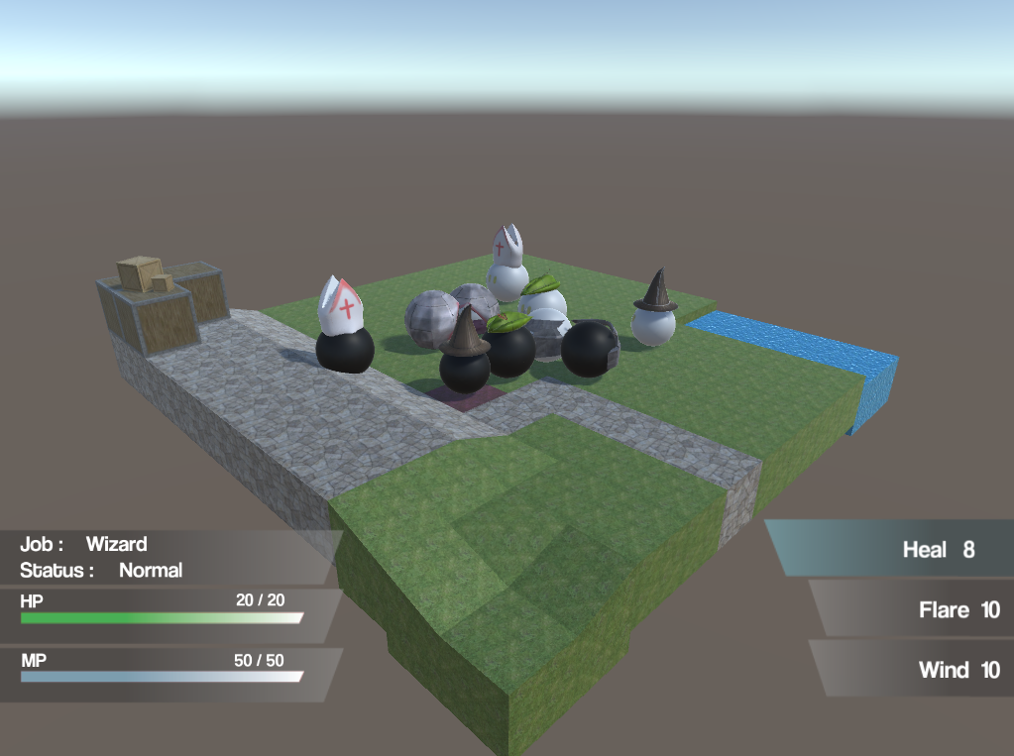

**Controls**

Enter – Select chosen spell

Right shift – Previous menu

**Spell Select**

1 – Spell name

2 – Spell Cost

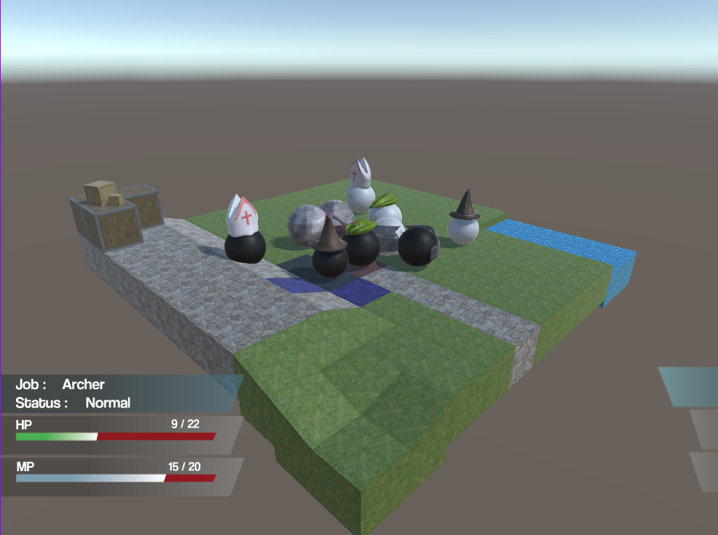

**Controls**

Enter – Select target

W, A, S, D – Move pointer

Right shift – Cancel Action

**Using a Spell**

1 – Spell cast range

2 – Target

3 – Target stats

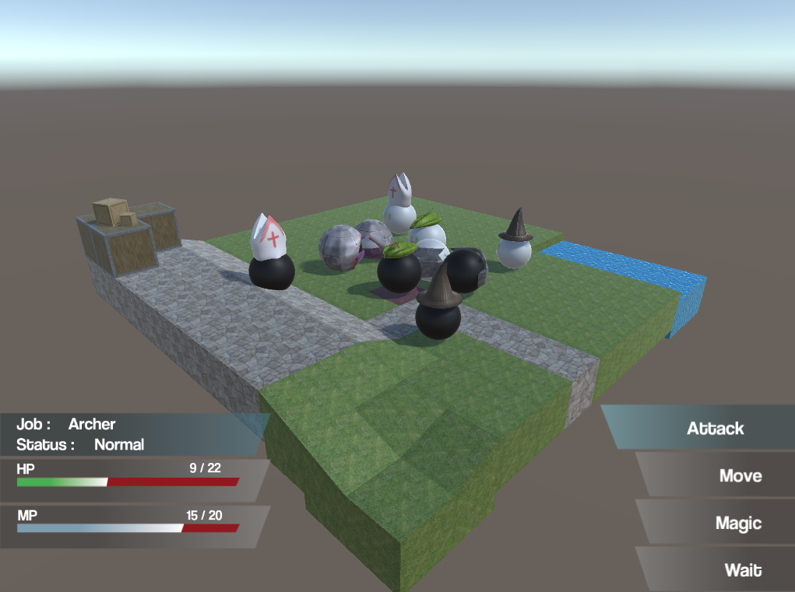

**Stats Bar**

1 – Pointer on ally

2 – Pointer on opposition

3 – Pointer on self

4 – Health points

5 – Mana points

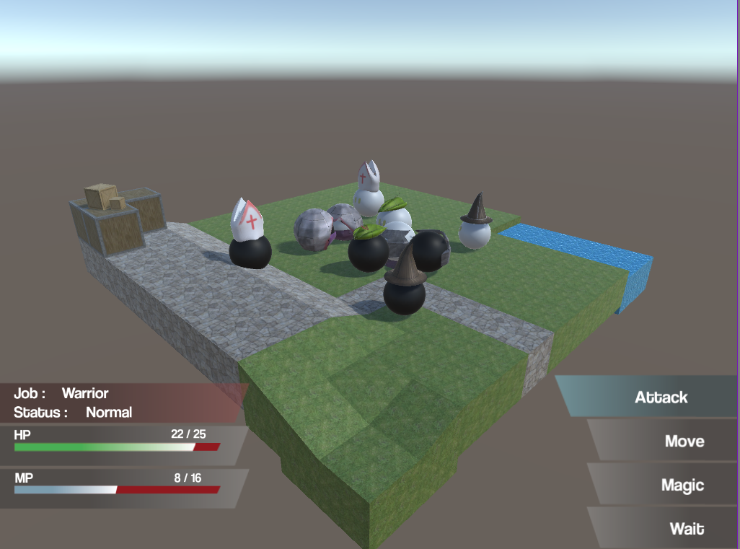

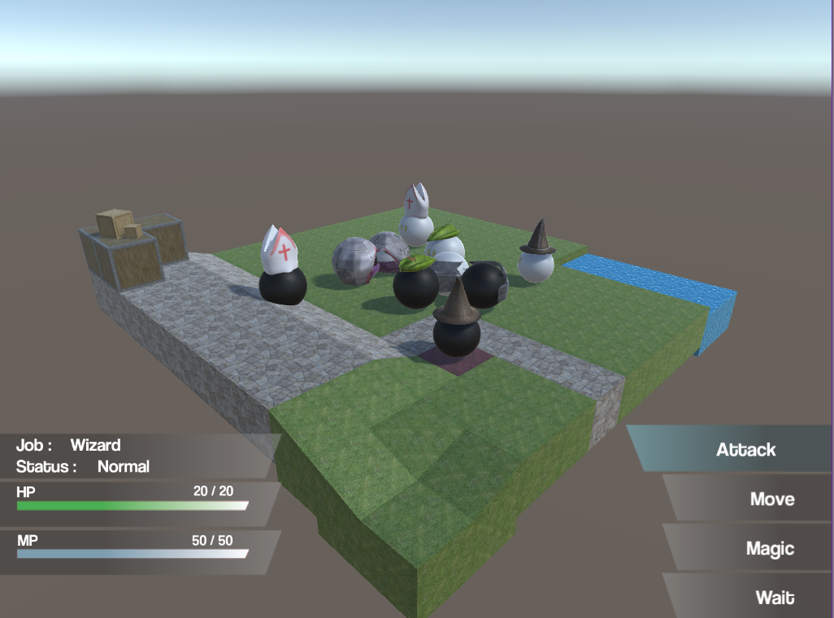

# Final Adventure PID PROCO304 Daniel Bendell

### Introduction

Final Adventure is a turn based strategy game (TBS) that is being developed for PROCO304. It will be an isometric based environment where the player or players have to strategically manipulate their characters around the map and defeat their opponent. Unlike most traditional TBS games this will focus on the player’s movement, making them place and move their characters in suitable positions depending on the fighting situation.

### Background/Motivation

The reasoning behind this project idea is my personal love towards TBS games and how they engage the player, making them apply real strategic actions in order to make the best of a given situation. TBS games give the player several different options when playing a game. Granted, there is generally a good and a bad way of playing them, which either makes the process easier or harder to complete, but this level of diversity really attracts the user’s attention.

Seeing that programming and developing games are my hobbies and the areas I wish to work in, I see this as a fantastic opportunity to further develop my skills, as well as give me the chance to put a large amount of time and focus into a single project. During full scale development I normally shy away from games as they require a diverse skill set and I like to focus on the programming, however this should prove a tremendous challenge and will test my ability to properly manage a project and scope out the initial objectives without trying to reinvent the wheel or development the newest form of gaming single-handedly.

### Project objectives

1. To analyse existing turn based strategy games, note pros and cons of similar indie developed games.

2. Analyse the areas of the projects I am less skilled in (Art, Modelling, Sound), formulate solutions to issues.

3. Analyse development environments, which one is going to be most beneficial, boost and aid development.

4. Scope out development mile stones, what is going to be key to make a minimal viable product, increase the focus on areas that are going to be most important.

5. To create an interactive TBS game that immerses the player in a strategy based platform.

6. To further enhance my programming and game development skills with a fully functional game.

### Initial scope

1. Identify indie TBS games that have a positive following or have done well within the market, note what I think they did that helped them stand out above the rest as well as what I would avoid doing and why. This will give me a strong starting point and a clearer idea of what is working within the current market.

2. Identifying the weaker areas of the project will allow for third party assets to aid the application, instead of spending valuable time learning how to complete extended tasks. Finding existing assets or create a simplistic theme that minimalizes the unwanted workload.

3. Finding a suitable development environment that is going to assist the game creation.

4. The proposed game will

A) Allow players to create or (possibly) join a hosted game

B) Allow players to place their characters in a specific formation within the map

C) Give players a variety of different characters to choose from

D) Allow players to complete actions within the players turn e.g. attack, defend and move

E) Apply changes to characters depending on the players actions, based on their stats

F) Have an end of game state notifying the players of the winner and loser

5. Modify interactions and work flow based on user feedback. This should give the game a better user experience instead of tailoring the game to my own specification.

5. Method of approach

There are several key features that will need to be in place before the game is even considered a minimal viable product. Key feature like, creating a game environment that allows user interaction, creation of in game characters that the player can choose from, all of which can move around the map, play against either AI or another player in real time, statistical changes to characters based on user actions (attacking an enemy). The game development has a range of different available platforms to offer e.g. Unity, Unreal Engine, CryEngine. Regardless of the final decision it will be written in C#. This will cover all of the game functionality without the need for additional tools.

Depending on the decided approach for the game one of the areas of development could be server side and database related. This would allow for multiplayer interactions and the use of saving and returning to game states. Possible technologies are ASP.net/SQLServer or Node.js/MySQL.

Creating 3D models is a possibility in this project so applications like Maya and Blender will be considered with Photoshop and Illustrator being used to create any 2D art work.

### 6. Initial project plan

|  |  |  |  |
| --- | --- | --- | --- |
| Stage | **Expected Start Date** | **Expected Completion Date** | **Products/Deliverables/Outcomes** |
| Initiation |  | 5 Feb | PID |
| Product investigation | Sat  6 Feb | Tue  9 Feb | Investigate existing products with similar concepts. Document positive development techniques |
| Research development environments | Wed  10 Feb | Fri  12 Feb | Look into which development environments are going to make it easiest for me to create the product |
| High level design | Sat  13 Feb | Thu  18 Feb | Designs for game architecture, database structures, API calls, basic level design |
| Development stage one | Fri  19 Feb | Fri  4 Mar | Minimal functionality, integration of extending applications e.g. database, server |
| Development stage two | Sat  5 Mar | Sat  19 Mar | Full integration with extending applications, additional functionality for core game mechanics |
| High level UI & level designs | Sun  20 Mar | Wed  23 Mar | Designs for interactive user interface and models. Look into third party assets or begin creating assets |
| Development stage three | Thu  24 Mar | Thu  7 Apr | Finishing of core functionality, review minor tweaks and bug lists |
| Initial testing & debugging | Fri  8 Apr | Wed  13 Apr | External reviewing on current product, formulate suggestions and opinions on improvements |
| Development stage four (Optional) | Thu  14 Apr | Thu  21 Apr | Apply appropriate user feedback to production |
| Complete report | Fri  22 Apr | Fri  6 May | Finished report, after review and feedback |

### 6.1. Control plan

The following PRINCE2 control techniques will be employed:

Highlight reports weekly until Easter and at the end of each stage thereafter (to include stage reviews at stage completion)

Weekly review meetings with project supervisor until Easter and as needed there-after, to review progress, plans and products

Risk management (see Section 7)

Communication plan (see Section 6.2)

Quality plan (see Section 8)

Exception reports and plans as necessary

### 6.2. Communication plan

Review meetings will be held with the supervisor in line with the Control plan.  
Further ad-hoc communications will take place as needed.

### 7. Initial risk list

|  |  |
| --- | --- |
| Risk | **Management strategy** |
| Under estimated stage timeframe | Regular meetings with my supervisor will allow for early signs of under estimation and a reiteration of the project plan will be produced |
| Difficulty learning new software | Detailed research and evaluation will need to be completed for each piece of unknown software. Creating rough prototypes to give a better understand might be possible depending on available time. |
| Over scoped application | Regular development stages are going to be completed along with progress reports to ensure that the end scope is still possible at every stage. A review on the final product and the MVP functionality will be needed if the scope seems out of sight. |
| Creating assets consuming too much time | I am going to look into third party assets to use within the game. If this is not possible, I will need to create them taking up a lot of time and effort. Reassessing the level design and user interface to make it more simplistic would be appropriate. |
| Loss of data | All work is going to be backed up with version control to ensure that it is available on any computer and it can’t be lost with machine failure. |

Game Engine Comparison

Before any development begins it is vital to ensure I am going to be completing it on a platform that works to my benefit. Throughout this document I doing to be assessing several options, all of which I see as a viable options to be the foundation of my project.

With the help of Strengths, Weaknesses, Opportunities, Threats (SWOT) diagrams I am going to be breaking down the game engines to understand their strengths, all of which should aid me with development, their weaknesses that may cause problems, the opportunities they offer to produce a high quality application and finally the treats to me as a developer, given my experience and goals for the project.

Unity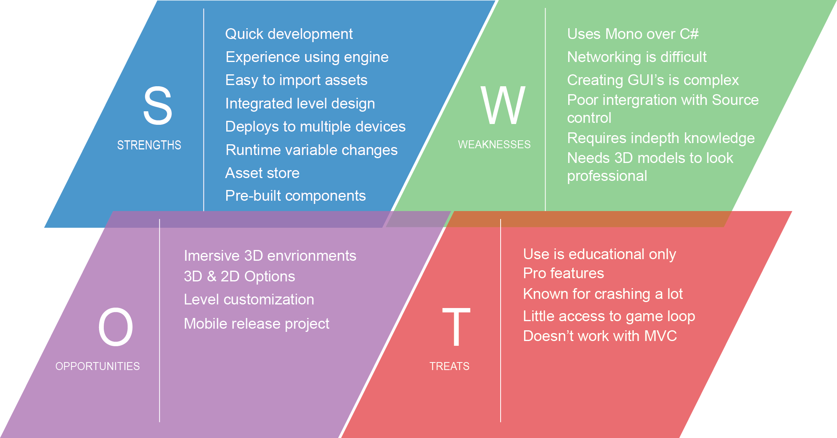

Before assessing the chosen options Unity was seen as my personal favourite. The reasoning behind this is that I have had a fair amount of exposer to Unity, although it was not to a very high standard it puts me in a better position when starting development. The main vision for the project is a 3D environment that has a chess board shaped map in the centre of the camera. I know this will be achieved without much effort using Unity due to creating similar levels in the past.

The vast amount of support that the Unity community has made available through the stack pages and their docs will aid my development. This should allow me to overcome any issues that arise during development and I would hope to relay my experience to help others by personally answering questions.

A big concern I currently have is the need for 3D model assets, I need to either create them myself or find somewhere or someone that can provide the required models. Luckily Unity has a thriving Asset store in which I may be able to buy or even better find free models to use in my game.

An issue known with Unity is its need to learn Mono, although this isn’t as bad a learning a completely new programming language it is going to cause development to slow. Along with this Unity does not have support for networking which could be an issue when I want to connect two players to the same game session. I have read that there are ways around it but the best alternative is to start from scratch and create my own. This would take up a large amount of time and I don’t know if the payoff will be beneficial enough.

One of the main problems I have previously encountered with Unity is that it does not match up well with source control, for each Unity element it will create a .meta file. These soon add up and have been labelled as the problem, however I found that the sheer size of a Unity project can be a big overwhelming for source control.

Another problem I have run into is creating a project that applies to the MVC framework. This is vital to ensure that the project is being built to be adaptable, scalable and easily to abstract. This is not the case with Unity with all of its assets being stored in the level design or used through prefabs.

## Unreal Engine

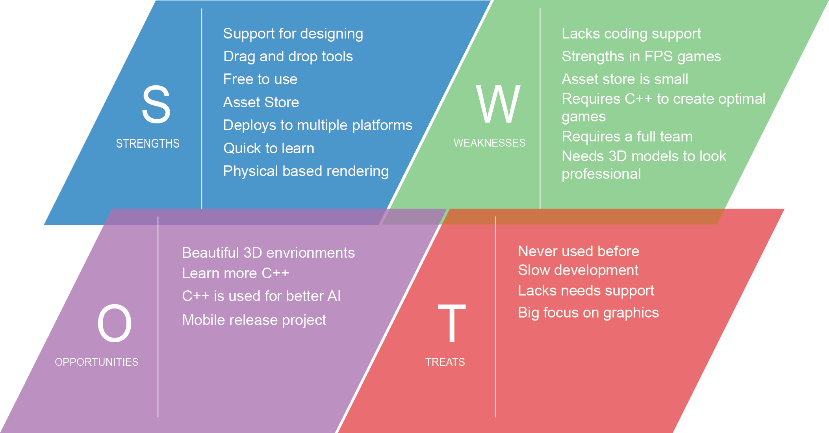

Unreal Engine has always been a strong competitor to Unity, with massive AAA releases. Due to this it was one of the engines I decided to research and asses its strengths and weaknesses towards my project and my development style.

First of Unreal games are beautiful. This is mostly because the games created on the engine are made by massive companies with hundreds of employees, however the option is there to make a game that truly is wonderful to look at. All this being said I have seen mixed reviews in regards to it being an easy engine to pick up. Some say when using the Blueprint drag and drop development tool it is a quick way to get into making your own games, however to create anything that really uses the true potential of Unreal you need to have a deep understanding of C++ and this is a massive issue for me as it has a very steep learning curve and would require a vast amount of learning before any development would begin. This being said it would be a fantastic opportunity to learn more C++. Just like Unity, Unreal has its own asset store. It has been noted that the Unity store has a lot more to offer to a beginner but this should deter me from using Unreal as there as still external resources available that can be imported.

Unreal was originally build with first person shooter (FPS) games in mind, which has had a massive effect on the games created within the engine. Seeing as my game does not require these features I am unsure it will be worth the steep learning curve required to develop a turn based strategy game.

## Adobe Air

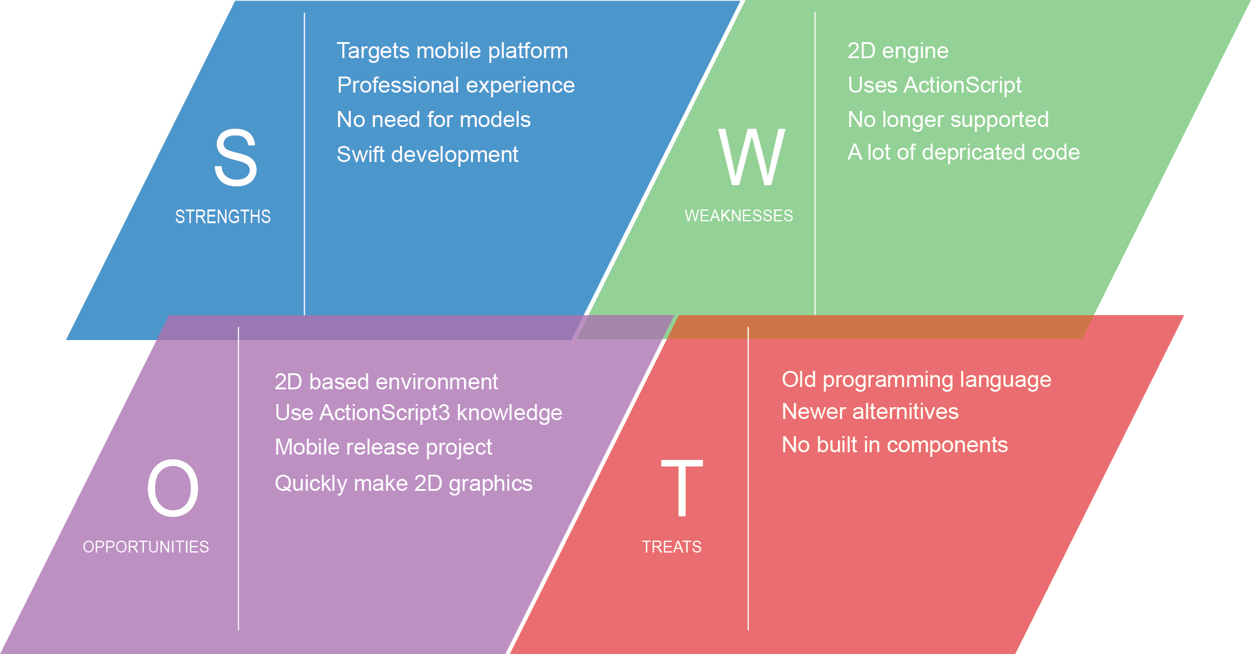

Although Adobe AIR may seem like a strange choice when looking at developing a game on this scale, however flash games have been and still are extremely popular. This still is not the only reason I decided to research about AIR. During my placement year I was part of a team that used AIR to create a very impressive whiteboard animation application. I was able to see AIR for its true potential.

Although this would limit my application to a 2D environment it would cut out a lot of the excess I have been worried about. First of all I would not have to look for or create any 3D assets. I would only be concerned with 2D assets and I am happy creating them as I have had a lot of practice in the past. Second of all I would be able to jump straight in with development seeing as I have a year’s professional experience with this platform. I already know the ins and outs of ActionScript3, meaning I could tailor the project to its pros.

All this being said Adobe AIR is now no longer being supported which is a humongous problem if I wish to take the development of the game any further in the future. Even if it is not being supported any longer the vast amount of support that has been raised in that past 20+ years is still available online, which should stop me from running into any problems with development.

## Conclusion

After researching about the three possible developing environments I personally think there is a clear winner. They all have their own strengths and weaknesses, all of which could make the project amazing or restrict it in some way.

I don’t believe that using Adobe AIR is going to help me further my developing skills and could hold me back in terms of the potential of this project. Due to this I have decided against using AIR. Which leaves either Unity or Unreal? Both of which will allow me to create a wonderful game, both visually pleasing and offering the elements needed for a solid 3D game. Due to the fact that I am more familiar with Unity and am able to program using Mono C# I have decided to use this as my game engine. I know that both of them present strong benefits but the need to use C++ in Unreal was a big turning point. C++ is a very professional programming language and used throughout the gaming community however there is a need for speed and C# mixed with Unity offers that.

# Game Design Document

## PRCO304 – Final Adventure

Bayesian’s Probability Controlled Artificial Intelligence in a Traditional Turn Based Strategy Game

GDD Written by: Daniel Bendell

Table of Contents

Overview 4

Theme 4

Core Gameplay/Mechanics 4

Character Selection 4

Strategic Battle Formations 5

Global Pointer 5

Movement 6

Interactive UI 7

Actions 7

Target Platform 7

Influences 8

Worlds of Magic 8

Final Fantasy Tactics War of the Lions 8

Warhammer 40,000 squad command 9

Unique Selling Point (USP) 10

Development Objectives 10

Story 11

Characters 11

Archer 12

Wizard 13

Assassin 14

Priest 15

Warrior 16

Spells & Abilities 16

Heal 16

Flare 16

Wind 16

Slash 16

Focus 17

Assassinate 17

BloodBlade 17

Level 17

Art 18

Sound 18

Controls 19

# Overview

With the forever growing popularity of computer based games, it is becoming essential to create unique, engaging and powerful artificial intelligence (AI) systems.

The aim of Final Adventure is to create a turn based strategy game that can be played against the computer in the form of AI. Final Adventure offers the players a vast set of characters all of which has a varying set of spells and abilities to aid them within the strategic battle field. The player must carefully manipulate their units around the environment which engaging in tactical warfare. The victor will arise when only one team remains.

## Theme

The theme for Final Adventure follows a fantasy based realm in which a group of trained fighters must battle to the death. Set in an old age that focuses on the medieval fighting and magicians secrets.

## Core Gameplay/Mechanics

This section covers the absolute core mechanics for the games functionality. These elements are the bread and butter of the game. The majority of the development focus has gone toward these elements and will continue to expand as the game does.

### Character Selection

This is the first section of the game that truly involves the player which increases the need for it to be a spectacular mechanic. This will instantly either make or break the game to a vast amount of the audience. It needs to involve the player, showing them what the game is capable of and how it is going to continue to draw them in as they begin to play the game.

The character select boasts a carousel of all the available characters, using simple rotating animations to draw in the player’s attention. Not only does it show off the set of characters but their traits, strengths and weaknesses. This straight away gives the player something to think about, allowing them to form up battle techniques before the game has even started.

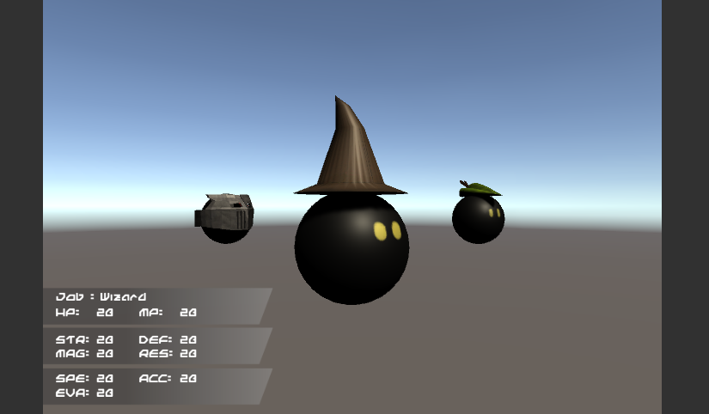

### Strategic Battle Formations

When the player is cruising through the character carousel they will be placing their characters within the available map locations. Much like chess they player will be forced to the one side of the map as this allows for tactical spacing between the two armies. The player will place all of their characters into a formation that best suits their battle type and proceed to play the game.

### Global Pointer

In game the most important element of control is the global pointer. This can be moved at any point within the game apart from when an AI is completing their turn. The global pointer allows the player to gain information about their own team as well as the opposition. Although it doesn’t show all the details is will display the characters health, mana and class type if moved to their position. Otherwise the global pointer is used to complete movements, actions and other important mechanics.

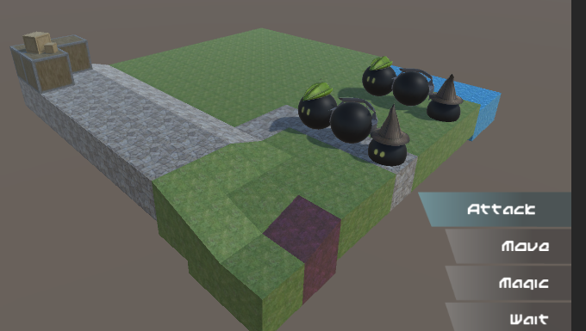

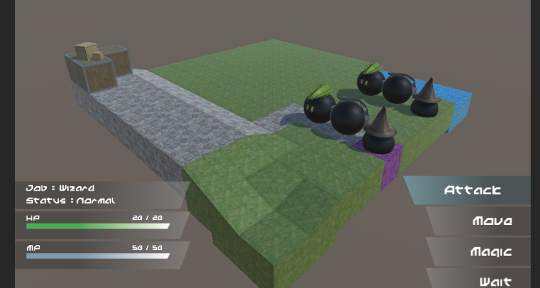

### Movement

When the players turn begins they have the option to move their characters. Moving the character is very important within the game as it allows the player to group, disband, advance or retreat in a battle scenario. The movement is completed based off of the characters speed value. This varies from character to character so makes it a very important aspect when choosing your starting team. The movement of a character is vital if they wish to engage in combat as not every character is able to attack from range. In fact very few of them are.

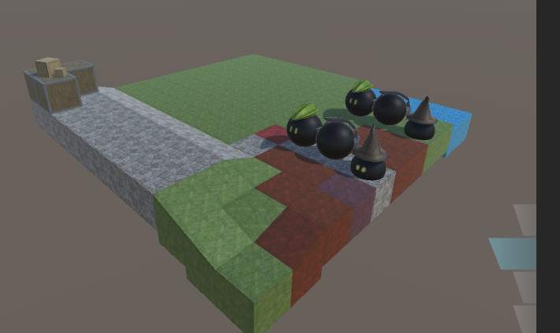

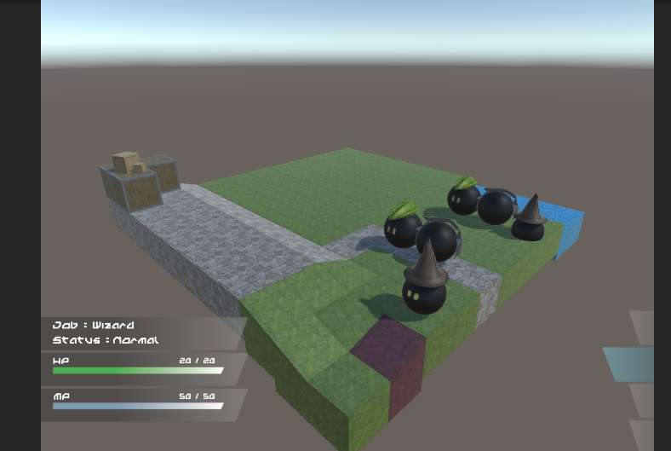

### Interactive UI

When playing a TBS game a large amount of the games focus is driven through the UI. This is because TBS games are fairly slow paced making it easy to manipulate game play with UI. If the UI is not interactive the game feels boring, slow and does not immerse the player. This is why it is very important to build a UI that is pleasing to use.

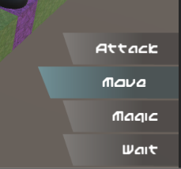 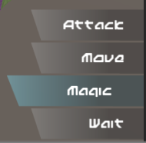  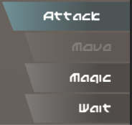

### Actions

Actions consist of five main options. Attacking, moving, spells, abilities and waiting. Each one of these options is what form a characters turn. They are able to complete two actions as long as one of them is movement. Using the actions to move around the map, attack the opposition or aid a friendly character are what make this game so exciting. All of the actions have been broken down into separate more detailed sections of the GDD.

## Target Platform

Although a lot of different platforms were considered the game is being targeted towards PC. This eliminates any need to tailor it to mobile and the thousands of different specs. The chosen platform allows the game to be built as a prototype for a larger scaled application, opposed to a polished game that would need serious testing and additional features if the target was console. Developing for PC means less focus on the games overall performance and more on the core game play. If the resources were available (Mainly time) the performance would be a greater concern.

# Influences

## Worlds of Magic

http://myworldsofmagic.com/

A great thing about Worlds of Magic is that it was developed and created using Unity. Which is the game engine used to build Final Adventure. It is a simple yet very well executed game with very similar mechanics to the game created. Players work their way through a range of different battles fighting their way to victory and slowing exploring the world.

Worlds of Magic uses a map terrain that is very much alike the one used in Final adventure. Although it might have more to offer in terms of scenery the use of a square based environment is awesome.

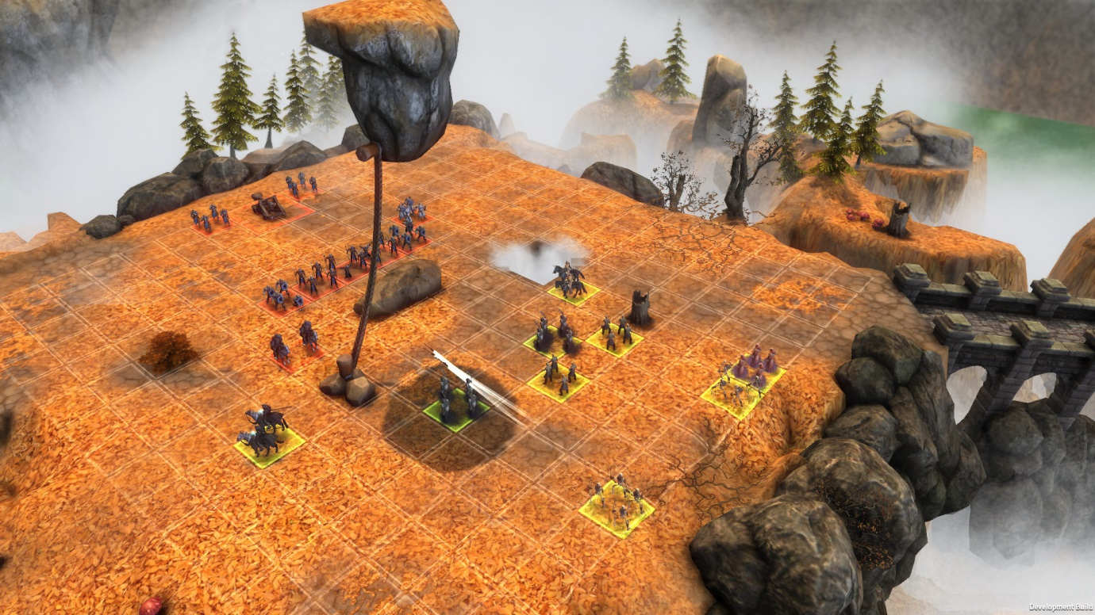

Something I really enjoy about Worlds of Magic is the out of range environment. It really brings the map together. It helps create a unique feel to all the different battle arenas. The angled view and open environments has been a key area of the game that has made an impact in how the camera view is used and the environment created for Final Adventure.

## Final Fantasy Tactics War of the Lions

A popular game with successful releases on mobile, PSP and PC. Tactics War of the Lions offers a humungous story line that truly is breath taking. With very challenging battles, this game can seem a little harsh but it really does bring out the true meaning to tactical warfare.

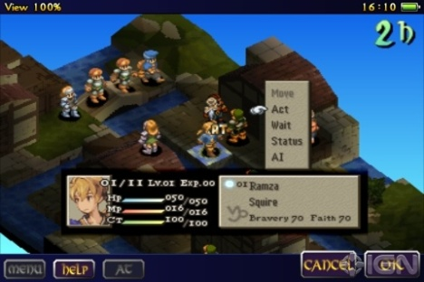

The simplistic environments and UI really help this game excel and act as such a strong inspiration towards the project in hand. I love the way the characters are manipulated around the map with the simple highlighted floor tiles. This has been a huge inspiration towards the controlling of the characters within the completed project.

## Warhammer 40,000 squad command

https://en.wikipedia.org/wiki/Warhammer_40,000:_Squad_Command

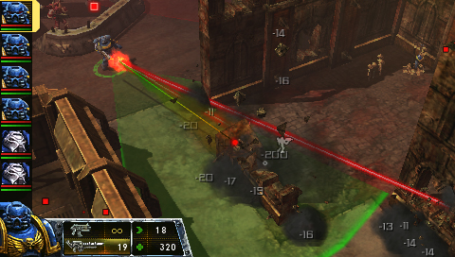

This game mimics the style of a table top game like dungeons and dragons. Giving the player a lot of freedom within their movement and attacking. The game uses very simple UI and strong map graphics considering it is originally a PSP game. Being able to see your team’s stats within the side of the map is very convenient as you know how you are doing overall. The attack range is clearly visible within the environment and the damage done is clearly displayed as the action takes place.

# Unique Selling Point (USP)

The USP of Final adventure is without a doubt the AI system in place. Without the AI the game would be another simple player vs player match up. This would be a great feature to apply within future development; however the challenge of creating an AI that will test the player is more appealing. Ensuring that the AI works and acts as expected is an important factor and can be seen as the make or break of the project.

When the AI is assessing it turn, it needs to find a target either on the opposition team to attack or on its own team to heal or aid in some way. This is what really makes the AI work as if it was human controlled. It assesses so many different aspects of the game to ensure it is making a decision that will benefit it within the future of the game.

Along with its decision making, the assessment it makes of the opposition is also key. The AI technique used is based on the Bayesian probability system. This is where the AI tries to predict the human’s actions and these probabilities will play a massive factor in what they decide to do.

However putting all the eggs in to one basket isn’t always the best thing to do. Because of this another selling point of the game is the simplicity of how it is played. Much like chess the player is very limited with what they can do with the characters. This forces the player to really think about what they are doing as each move is going to be extremely important.

# Development Objectives

|  |  |  |
| --- | --- | --- |
| MVP |  |  |
|  | Complete a competitor comparison | ✔ | |
|  | Analyse development weaknesses | ✔ | |
|  | Research and develop and AI system | ✔ | |
|  | Create an interactive UI | ✔ | |
|  | Learn to model and texture simple assets | ✔ | |
|  | Give the players a variety of characters | ✔ | |
|  | Make character unique with special traits | ✔ | |
|  | Create game that involves strategy tactics | ✔ | |

|  |  |  |
| --- | --- | --- |
| Additional |  |  |
|  | Integrate Learning AI | ✔ | |
|  | Create levelling system to allow in game progression |  | |
|  | Offer a set of environments to play in |  | |

# Story

In the games current state there is no story line in place. This however is defiantly an area in which further development will focus on. The need for an AI system that works well is more important that a story line in its current development state. Now the AI is complete, it might require a few adjustments but the main bulk of it is complete. With the finished AI the game will be able to generate several different maps, AI scenarios and mould it around a story line to engage the player even more.

Much like the FF Tactics War of the Lions game I would love for the game to have an in depth story line that involves the user. This will act as the inspiration for the next steps of the story development.

# Characters

In the games current state there are only five different characters to choose from. The main reason behind this is because the player must choose a set of five characters and I wanted there to be the option for five different characters. The structure of the game has been made so it can easily implement more characters with new unique strengths and weaknesses, however the need for more models and textures is holding this up. The models used are very basic and handmade, but if the game was to expand to more characters I would like to revise their models or outsource it to a client. This would ensure that is it made to my own specification.

## Archer

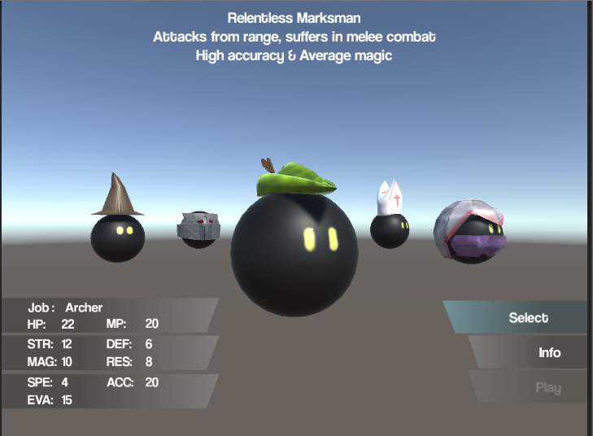

The only ranged character within the game. Able to attack enemies from a distance but not able to do any damage within melee range. The Archer has average stats, however they have high accuracy and evasion. This allows them to almost always hit their target, and a higher chance to dodge an attack. The use of a ‘Robin hood’ hat to resemble the character.

## Wizard

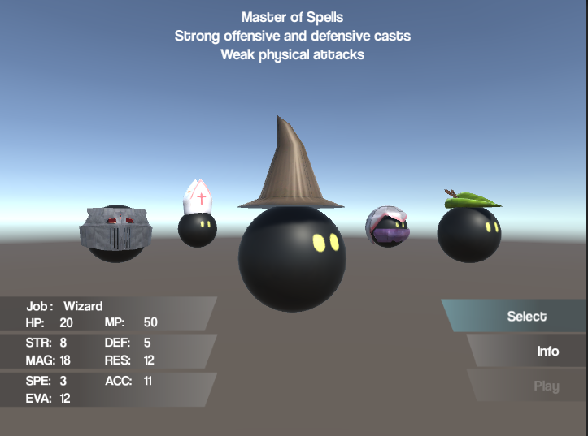

The wizard offers high damage offensive spells as well as a strong heal for allies. Very weak in terms of physical damage and defence. The high mana pool allows the wizard to cast a lot of spells before resorting to the less effective attacks. Doesn’t have much health so best to attack with magic and then retreat to a safer distance. Using a traditional wizard hat as its trademark look.

## Assassin

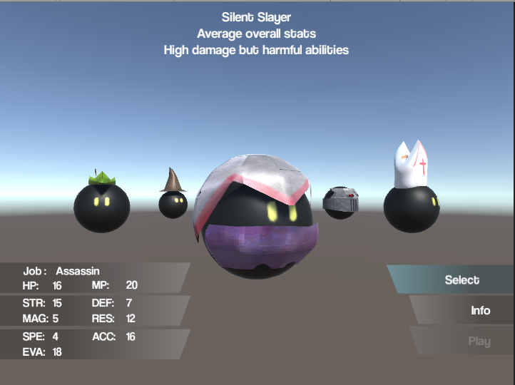

The assassin is my personal favourite in terms of utility. All of its stats are either very strong or weak, allowing for some interesting play types. The assassins abilities are more situational that anything e.g. assassinate is stronger the lower the targets health, blood blade damages for a lot but also hurts the assassin in return. The look for the assassin is based off the assassins creed characters with a white hood and cloth mask. Very hard to model a sphere character with a hood so is one I would like to revisit.

## Priest

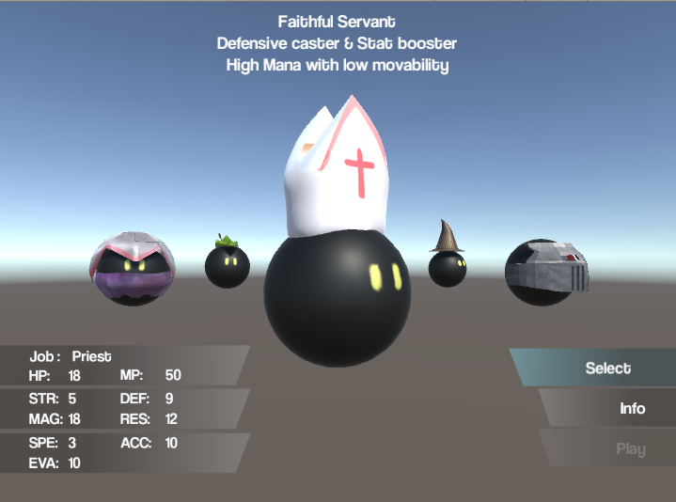

The priest was the newest addition to the game and inspired due to the lack of magic based characters. Much like the wizard its strengths lay within magic but more defensive that offensive. Used to heal and mend ally characters than deal damage to the opposition. A priest is great for keeping your characters healthy within battle. Has a pope styled hat with a cross on, to show that he is more peaceful that the other characters.

## Warrior

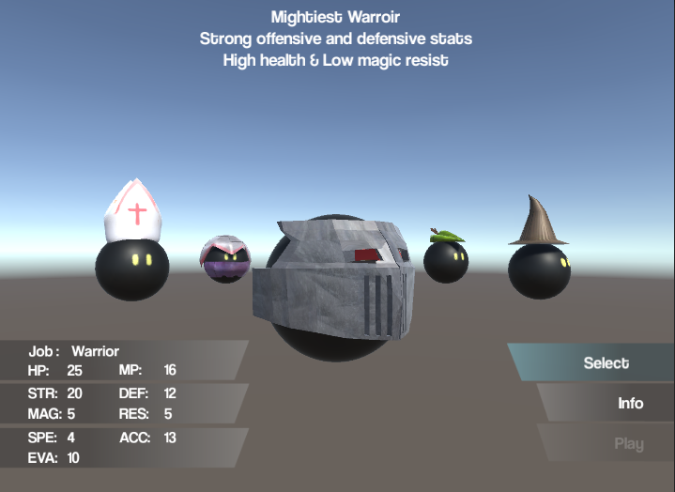

Finally the warrior! Although the helmet looks like the front of a train it is meant to be a helmet. Although the thought of an oncoming train is just as scary. Again a very tricky character to model as a traditional medieval helmet would cover the entire character. The warrior’s strengths lay with its high health pool and physical attacks. Used as a front line man to absorb damage, yet the power to deal it back if needed.

# Spells & Abilities

## Heal

Available to every character however it is not very useful to characters without a high magic stat. Using mana to heal a character within a close range.

## Flare

A fire based spell used and effective against all character types. Available to the wizard and priest only.

## Wind

A tornado of fury cast by only a wizard, effective against all character types.

## Slash

A strong physical based attack used by the warrior. Stronger than a normal physical attack but uses up a large amount of mana, needs to be used wisely.

## Focus

The archers main source of power. Increased the accurate stat and deals a high amount of damage to characters with low defence.

## Assassinate

The assassins main attack, used to deal more damage based on the characters health lost. The more health lost the stronger the attack.

## BloodBlade

Another assassin based ability used to deal strength based damage onto an enemy at the price of being damaged itself.

# Level

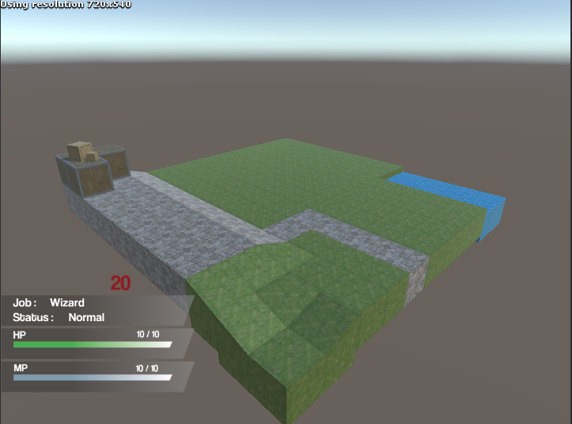

The only level currently available for the game is this grass 10 by 10 map. In the future more maps and environments will be created but the need for 3d assets is too high and the reason the level design wasn’t considered an important aspect. There are a lot more textures ready to be used, however they are going to be used to create different locations.

Ideally the future maps will consist of more complex environments (not 10 by 10). Making them bigger more complex to get around and other aspects will be interesting to explore. The aim of the current map was to redefine the chess board with a more artist feel. The map was also created in the level editor of Unity so would need reworking to make it more dynamic as this would allow the map to be created programmatically. The map needed to be simple much like the Worlds of Magic maps as the UI and surrounding elements are also simplistic. Overloading the map with too much could cause distraction. When a story line is put into place, the maps will be created to compliment it, bringing the visual aspect to back up the story.

# Art

Not much art has been used for this game, the UI is very basic and only uses a gradient based shape with simple text. The only bit of art used for the game is the main menu which consists of an abstract mountain view where the peaks highlight to represent which part has focus.

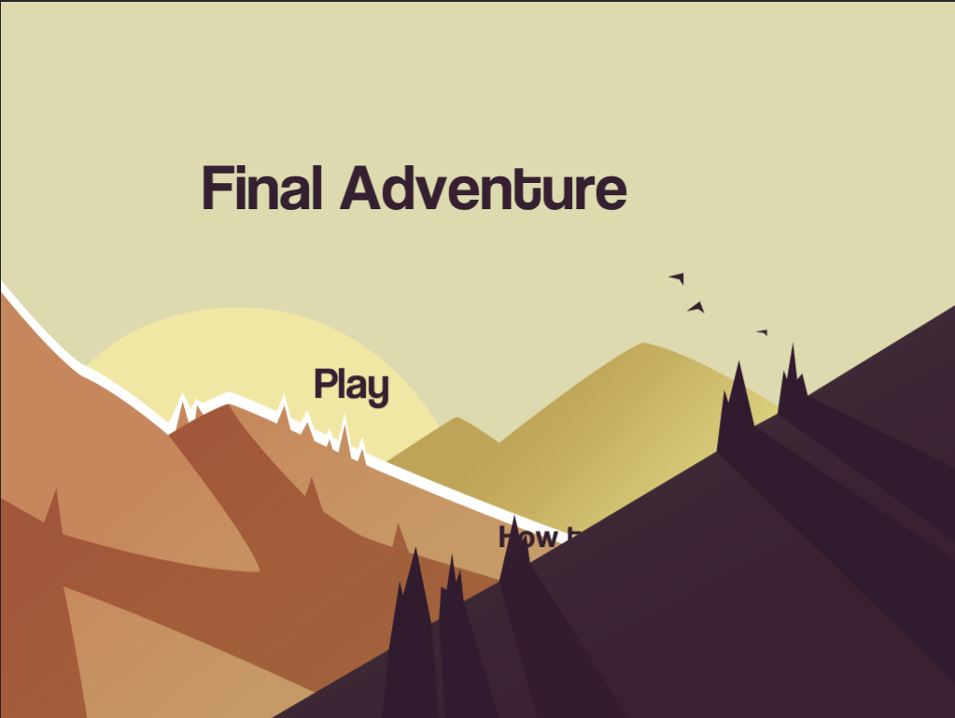

This was the only art made for the project, the rest is 3d models and their corresponding textures.

# Sound

Sound is a difficult source to create without a large amount of experience in creating it. Finding free or outsourcing the sounds of the game could prove to be a key, making the game more immersive.

<http://www.bfxr.net/>

Resources like BFXR could be used to create noises and sounds that go alongside the character actions.

So far the resource above has been used to create the sounds for all spells, attacking and death.

# Controls

The focus for the Final Adventure was to bring all of the controls to the one piece of hardware. The chosen piece of kit was the keyboard, although using a PlayStation or Xbox controller would have been just as effective, anyone who plays the game will always have access to a keyboard and is the reason behind it. The controls revolve around two, four directional movement combos. These being the arrows keys and the traditional W, A, S and D. For the most part the arrow keys are used with the menu, scrolling up and down the options, accompanied by the return key to select and the right shift to go back in the menu. Whereas the WASD combo is used to manipulate the in game pointer around the map. These are the only controls within the game, making it easy to remember and there is no need to move your hands away from the required sections of the keyboard.

Illustration Tool Test

# Illustrator

Illustrator is the tool I have had most exposer to in the past. I have used it for multiple different application and game designs. It allows for wonderful scaling assets that can be used very effectively as UI components.



Here you can see me testing out some designs for the Health and Mana bars. Illustrator has the pen tool that allows for custom assests to be created opposed to restricted shapes like squares and ovals. The simple gradient tool can be applied to all of the elements on the canvas which adds another level of detail to the assets created.

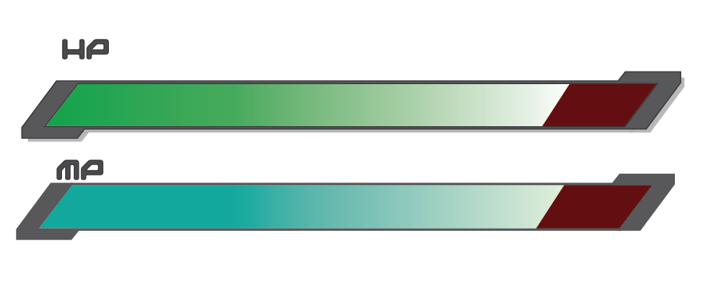

I then moved on to piecing the assets together. It was so easy to bring this together I am considering using it in the game itself. I can create multiple assets that all revolve around the same theme seeing as the base sprite sheet has been created.

# Photoshop

Photoshop is the only other tool I have decided to test as I don’t want to spend too much time on testing and designing assets that might not be used in the actual game. As I have already attempted to create assets that will be displaying the Health and Mana bars of a character, I thought it would be beneficial to test another UI section. The section I have chosen to create is perhaps the most important of them all being the menu system I intend to plug into the game.The first asset created is very simple, yet it took much longer than I anticipated. This is mainly down to me not understanding how PhotoShop layers work and how to interact with the elements on each layer. However after the initial bump I was able to pull the next assets together rather quickly. The key feature I want to keep consistent throughout the game is the simplicity in assets and game play. Although the assets created on illustrator are a little more vibrant it was good to test out its potential.

One problem I encountered with PhotoShop is that the assets can be created from a range of shapes or drawn with the pen, brush or pencil tools. This would be a lot easier to do if I had assess to something like a drawing tablet, but creating custom shapes using only the mouse has limited the created quite a lot.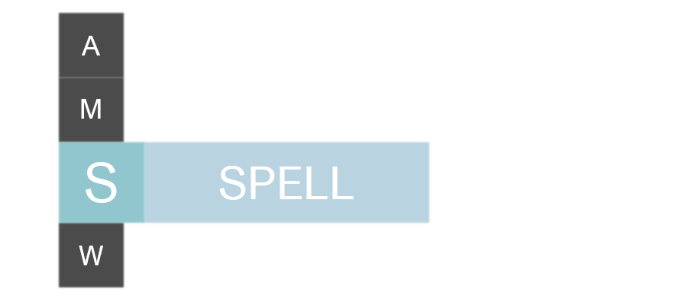

Next I was following the rules of simplicity, keeping the assets two a small amount of numbers, varying the opacity to give the effect of multiple shades and block based text. I really like how this design showcases the highlighted menu choice but I feel like it would have to be altered if I am going to use it in the game as the standalone letters aren’t clear to what they represent.

This being said I really like the design. I would like to play around with this design more and possibly test it in illustrator to see which is easier to complete and alter.

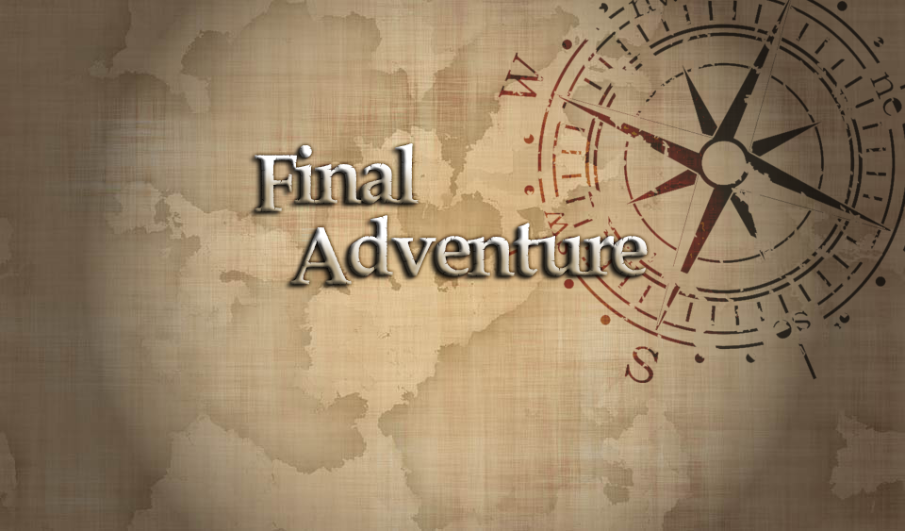

Finally I wanted to mock up a main menu design. Knowing that PhotoShop works well with multiple images and layering them on top of each other, I wanted to test this. It did take a series of google searches and youtube videos before I was able to understand how to burn an image into anothe, remove a specific colour from an image and add the torch like effect. I am really happy with how this turned out and realize that this is going to be a strong pull factor for using PhotoShop. I may even use this within the game, however it doesn’t match the UI designs I made earlier so either one will need changing.

# Conclusion

Overall both tools are extremely useful and I can see myself using both of them during the design stages of the game. This being said Illustrator was so much quicker in building and completing the assets. I spent a lot more time using PhotoShop as I didn’t know how to use it, but the learning curve the might prevent me from creating quality assets in a short amount of time is really the main deciding factor. If the UI takes a more artistic route I may revisit Photoshop, but for now using Illustrator is going to allow me to make simple custom images, whilst taking advantage of all the tools I already know how to use.

Artificial Intelligence Research

Artificial intelligence is completely new to me as a developer and I hope it is going to be a beneficial learning experience as I would like to explore the uses of AI further in the future. Knowing that my exposer to AI has been next to none my super visor was kind enough to suggest looking into either the Min/Max or possibly Bayesian inference.

# Maximin

The Maximin technique is a method of tree searching. It is used to either maximize or minimize the payoff of a given situation. So a very basic example would be two characters playing a game where the money used in the game determines whether a player is winning or losing. The more money the better the player is doing. When searching through the state tree the player with the most money will want to maximize this advantage by gaining more. Whereas the player with less money, will want to minimize the chances of the ‘richer player’ gaining money. This is very well explained in the paper Introduction to AI Techniques. Available at <http://web.mit.edu/sp.268/www/gamesearch.pdf>

An issue with this tree searching technique is that there is the possibility of the tree being almost infinite or simply too big to explore. This issue has been tackled in several cases using a basic heuristic that will remove any of the tree paths that exceed the given criteria.

<https://en.wikipedia.org/wiki/Minimax>

<https://www.cs.cornell.edu/courses/cs312/2002sp/lectures/rec21.htm>

<http://intelligence.worldofcomputing.net/ai-search/minimax-search.html#.VznmnvkrKUk>

Although this could be a very interesting use of an AI technique its implementations seem to be based on information that is available to the games current state. This will not be the case with the proposed game. The game in development will require the AI to assess possible outcomes to a variety of different situations opposed to maximizing its advantages over the opposition each and every turn. Maximizing its advantages is obviously a key part of the turn based strategy game play style, but the AI needs to anticipate the opposition’s actions instead of acting upon them.

# Bayesian

More specifically I have looked into the Bayes probability theorem. The Bayesian technique can be used for a number of different mathematical problems however after looking through them and seeing what they aim to achieve it was clear that the probability side was going to be the key area to research. “Bayesian probability is one [interpretation](https://en.wikipedia.org/wiki/Probability_interpretations) of the concept of [probability](https://en.wikipedia.org/wiki/Probability). In contrast to interpreting probability as [frequency](https://en.wikipedia.org/wiki/Frequentist_probability) or [propensity](https://en.wikipedia.org/wiki/Propensity_probability) of some phenomenon, Bayesian probability is a quantity that is assigned to represent a state of knowledge,[[1]](https://en.wikipedia.org/wiki/Bayesian_probability#cite_note-ghxaib-1) or a state of belief.” https://en.wikipedia.org/wiki/Bayesian_probability. This was very interesting when I first read it as it summed up what I was picking out to be negative in the Maximin technique.

After reading through several articles I still wasn’t able to completely understand what it was attempting to achieve. From what I gathered it is where weightings are given to a range of assessed probabilities where the amount of known information in limited. So using random values or quantities as a model for any level of uncertainty and running the probabilities through these models to give an estimated value.

Knowing how to use this within the proposed game is not very clear however it could be used by the AI to guess what the player is going to do (The unknown) based on the surrounding data it has available to it, giving varying weightings to a series of different outcomes, allowing the AI to assess the possibilities.

<http://gamedev.stackexchange.com/questions/21519/complex-game-ai-for-turn-based-strategy-games>

Based on the above link a user explains the different approaches that can be used to create a seemly intelligent AI system in a turn based strategy game. The two areas that really strike me a possible solution is firstly the Operational AI system. This is where the AI assesses three main criteria, their current strength, the reinforcement of units and evaluating which fights to pick/avoid.

This is an interesting aspect that could be used within the Bayesian technique, seeing as the information available to the AI may be limited and the unknown could be given a weighted value. This will allow the AI to calculate the best areas to move, fight in based on the units around them. As well as comparing the strengths of individuals and as a whole team.

The second area is strategic AI. This is where a range of elements are evaluated and each given a score towards the intended goal. For example, deciding where to move a character, the AI will evaluate all of the given spaces, and give each open space a score based on how far it is from surrounding AI or human controlled characters and other variables. This method could be used for a number of other sections of the game however this was the first to spring to mind.

<http://stackoverflow.com/questions/3275174/algorithms-for-realtime-strategy-wargame-ai>

This was an interesting post about AI in a war game, more focused towards real time strategy game but it points out that all RTS games and be broken down into decisions which is essentially TBS. In the answer to the question the user’s stats that it is important how much information you give to the AI as this can be what ranges the difficulty. Giving the AI all of the information to the given games allows them to perform to their maximum potential, causing the game difficulty to increase, whereas if the information is restricted the AI will be making decisions based on hunches making it more likely for them to produce errors. An interesting idea to think about when creating the AI system as it might be an option to give different Ai difficulty settings. This however is a big ask before the AI system has even been put into place.

<http://gamedev.stackexchange.com/questions/72230/techniques-for-an-ai-for-a-highly-cramped-turn-based-tactics-game>

Another interesting post where the idea for a TBS AI system is broken down into several sections allowing the AI to make decisions on a series of different data opposed to very linear decisions. It breaks down the game into influence maps or conflict maps that are used to assess the ‘Cramped’ map. It then goes on to the tactical and strategic decisions. It mentions that a neural network could be applied to make the AI learn over time, feeding off the output decisions made by the human controlled characters.

http://www.checkmarkgames.com/2012/03/building-strategy-game-ai.html

The above link is a series of blog posted created by a developer called [Harvicus](https://www.blogger.com/profile/05778633676064958982). It is a multipart blog in which he/she covers the creation of the AI system they have used within a TBS game. Many of the stages have videos attached showing the results of each blog post. Each post shows a considerable amount of information about the AI system in place, including code snippets. Going through this in more detail or as a reference when developing my own AI may prove very beneficial.

Bayesian Probability research

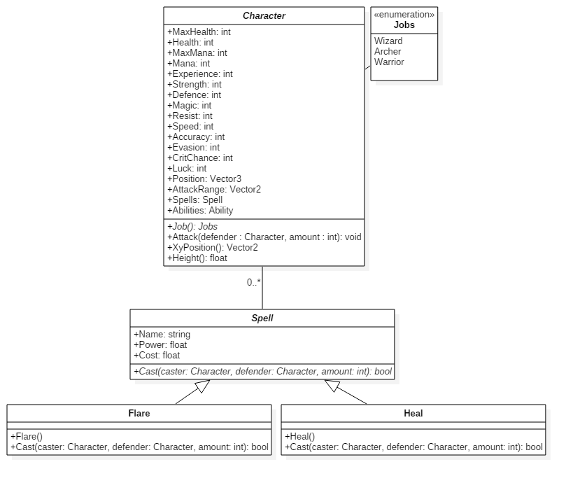UML & Flow Diagrams

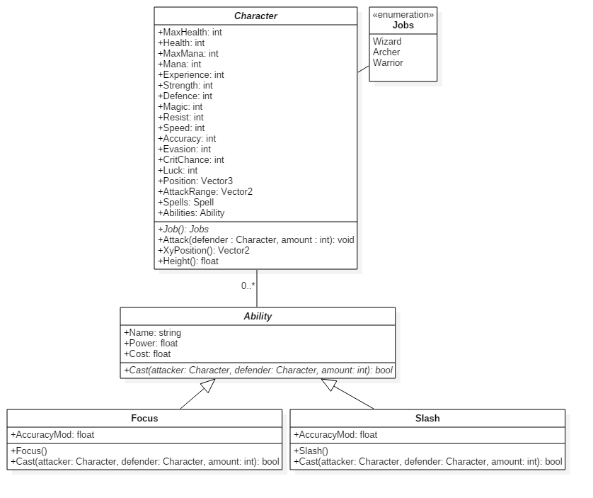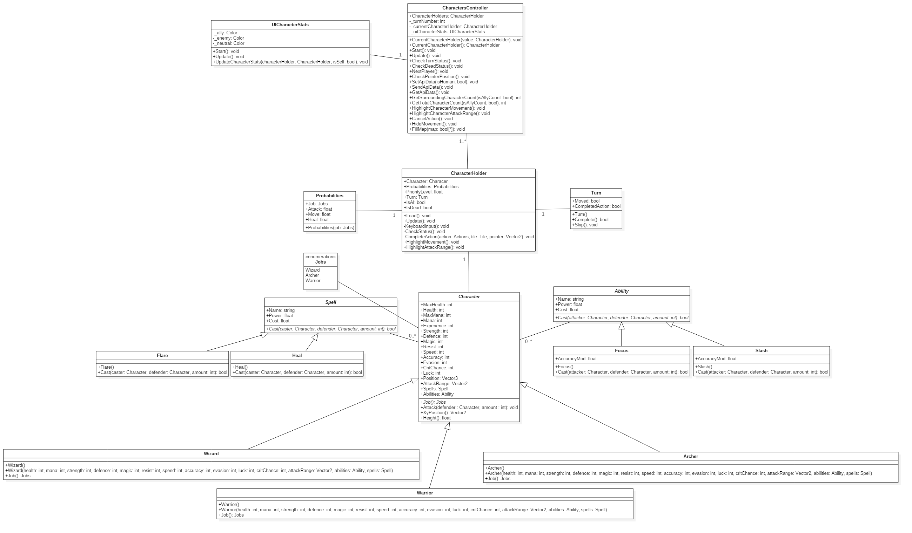







Database & API Structure

The decision to implement a database and API was very late in the game which is why it did not receive the same amount of attention as the rest of the project. It is also not one of the areas in which the project was going to place much focus. Instead it was a quick implementation to complete an additional task.

The database was created using SQL server 2014 and the data structure is very simple.

If the game was to expand and introduce a more in depth experience the database would hold additional data with expanding tables. The nature of the implemented API calls only required the data to be in a single format so the database shares these traits in a single table. If the database was to expand the data would be broken down into smaller and more specialize tables.

# Database Design

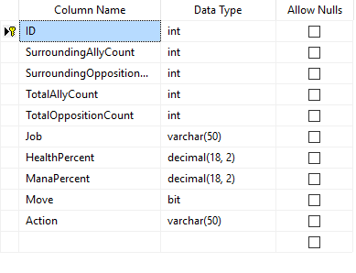

As states above the database is very simple, it is only used for one purpose and that is the storing and retrieving of one data transfer object. The elements stored into the database have been picked out as they are the key components within the AI formulas.

The database is stored on Microsoft Azure as it links very well with SQL server 2014. Using SQL server I was able to log into the azure database and query it without ever needing to go back to the azure portal.

# Server & API Calls

The API is set up on a very simple node.js server. The server doesn’t do anything fancy it just responds to two route calls required for the game.

First of which is a GET request to /api/Turns.

For this call to be successful the request must hold every database element from SurroundingAllyCount to the ManaPercent (See above). These variables are then passed into the SQL query as the WHERE attributes. The database returns all the entries from the database matching the corresponding parameters. This call is only ever made by the AI as the human controlled characters do not require this information. The information retrieved is then used to help formula the AI’s interactions within the game. As this element of the project was seen as an addition to the initial scope it was not given enough time to perfect. Given the game development had more time this is one of the areas that would see a lot of rework and refinement.

The second API call is the put request to /api/Turns

The game will take most of the information needed for the API at the beginning of that characters turn, as well as setting up the request call. When the player has completed an action and movement the API request will be sent, with the additional Move and Action attributes. It was done this way because the information used in formulating a complete turn is based on the variables or situation at the beginning of that characters turn.

The server and API are stored on a digital ocean droplet which has been linked to a Distelli build pipeline. This enables the API and Server to be updated as soon as the new code is committed to the Git Hub repository. Although this was not necessary it was fantastic practice for future work and is similar to the work flow a professional web application would follow.

To aid the debugging process of the API and Database a piece of software called Postman was used. This is a simple chrome extension or downloadable application that allows the user to experiment with the URL requests without having to run them in game. Without this the entire API development would have been a lot slower and more error prone.

Game Testing

|  |  |
| --- | --- |
| Test – Main Menu | Outcome |
| Moving between main menu options | ✔ |
| Selecting How To play | ✔ |
| Using the arrow keys should move through the how to pages | ✔ |
| Returning to the main menu | ✔ |
| Background music starting | ✔ |
| Pressing enter on the play menu option | ✔ |

|  |  |
| --- | --- |
| Test – Character Select | Outcome |
| Moving the character carousel | ✔ |
| Rotating the character model | ✔ |
| Displaying character stats | ✔ |
| Moving through the side menu | ✔ |
| Placing a character | ✔ |
| Changing the characters position | ✔ |
| Accepting the characters positon | ✔ |
| Character count | ✔ |
| Character limit | ✔ |
| Removing a character | ✔ |
| Going back to the character carousel | ✔ |
| Showing character information | ✔ |
| Displaying every characters information | ✔ |
| Hiding the information panel | ✔ |
| Play menu item enabled | ✔ |
| Going to the main game | ✔ |

|  |  |
| --- | --- |
| Test – Game | Outcome |
| AI generation | ✔ |
| Moving in game pointer | ✔ |
| Showing character stats | ✔ |
| Dynamic menu items | ✔ |
| Current character highlight | ✔ |
| Moving floor highlight | ✔ |
| Choosing a new position | ✔ |
| Menu disabled items | ✔ |
| Cancelling movement | ✔ |
| Attack floor highlight | ✔ |
| Ranged attack floor highlight | ✔ |
| Competing an attack | ✔ |
| Depleting health bar | ✔ |
| Displaying spells in menu item | ✔ |
| Using Flare | ✔ |
| Using Wind | ✔ |
| Using Heal | ✔ |
| Rotating the character model | ✔ |
| Waiting a turn | ✔ |
| Moving on to the next character | ✔ |
| Character death | ✔ |
| Pause menu | ✔ |
| Resuming play | ✔ |
| Exiting the game | ✔ |
| Display controls | ✔ |
| Closing the controls | ✔ |
| AI decision making | ✔ |
| End game - Defeat | ✔ |
| End game – Victory | ✔ |
| Returning to Main Menu | ✔ |

# Main Menu

|  |
| --- |
| Test – Moving between main menu options |
|  |
| Expected result – Using the Up and Down arrows keys will move between the two options. The white highlight should appear to indicate which one is currently got focus as well as the option text moving up. |
| Outcome - Pass |

|  |
| --- |
| Test – Selecting How To play |
|  |
| Expected result – When pressing enter, the page should move from the main menu and take the user to the new page, which explains how to play the game |
| Outcome - Pass |

|  |
| --- |
| Test – Using the arrow keys should move through the how to pages |
|  |
| Expected result – When the right arrow is pressed the menu should go to the next page in the how to, using the left arrow should go to the previous page |
| Outcome - Pass |

|  |
| --- |
| Test – Returning to the main menu |
|  |
| Expected result – Pressing the right shift should return the user to the main menu, also if the right arrow is pressed on the last how to page, or the left arrow key is pressed on the first page |
| Outcome - Pass |

|  |
| --- |
| Test – Background music starting |
| No image available |
| Expected result – When the game load the background music should start |
| Outcome - Pass |

# Character Select

|  |
| --- |
| Test – Pressing enter on the play menu option |
|  |
| Expected result – This will switch scenes to the character select scene |
| Outcome - Pass |

|  |
| --- |
| Test – Moving the character carousel |
|  |
| Expected result – Using the right and left arrow keys moves to the next or previous character in the carousel |
| Outcome - Pass |

|  |
| --- |
| Test – Rotating the character model |
|  |
| Expected result – Using the A and D key will rotate the character around, showcasing the model |
| Outcome - Pass |

|  |
| --- |
| Test – Displaying character stats |
|  |
| Expected result – The character at the front of the carousel should have their stats shown in the bottom left as well as their character description in the center top |
| Outcome - Pass |

|  |
| --- |
| Test – Moving through the side menu |
|  |
| Expected result – Using the up and down key will cycle through the available menu options |
| Outcome - Pass |

|  |
| --- |
| Test – Placing a character |
|  |
| Expected result – When the select button is pressed the camera will move to the map and place the chosen character into an available position |
| Outcome - Pass |

|  |
| --- |
| Test - Changing the characters position |
|  |
| Expected result – Using the W, A, S and D keys will move the character up, right, down and left. Only around the grey area |
| Outcome - Pass |

|  |
| --- |
| Test – Accepting the characters positon |
|  |
| Expected result – When the character is in the correction positon, pressing enter will save them into that position and return to the character carousel |
| Outcome - Pass |

|  |
| --- |
| Test – Character count |
|  |
| Expected result – When a character has been placed onto the map, the bars on the right will highlight |
| Outcome - Pass |

|  |
| --- |
| Test – Character limit |
|  |
| Expected result – When five out of five of the characters have been placed the menu should be disabled and all the blue highlighted bars filled |
| Outcome - Pass |

|  |
| --- |
| Test – Removing a character |
|  |
| Expected result – When the purple pointer is moved over to a occupied position it will give the option to remove them and disable the option to place a new character. Pressing enter will remove the character |
| Outcome - Pass |

|  |
| --- |
| Test – Going back to the character carousel |
|  |
| Expected result – If the user changes their mind they need to be able to go back to the carousel, pressing right shift will move the camera back to the carousel |
| Outcome - Pass |

|  |
| --- |
| Test – Showing character information |
|  |
| Expected result – When the info menu item is selected the more information window panel will appear |
| Outcome - Pass |

|  |
| --- |
| Test – Displaying every characters information |
|  |
| Expected result – Cycling through the characters with the information panel up will display the corresponding characters information. |
| Outcome – Pass |

|  |
| --- |
| Test – Hiding the information panel |
|  |
| Expected result – When the right shift button is pressed the information panel should be hidden. Or when a character is going to be placed |
| Outcome - Pass |

|  |
| --- |
| Test – Play menu item enabled |
|  |
| Expected result – When all five characters have been placed the play button in the side menu will be enabled |
| Outcome - Pass |

|  |
| --- |
| Test – Going to the main game |
|  |
| Expected result – When the play menu item is selected the characters will be transported to the main scene in their positions |
| Outcome - Pass |

# Game Scene

|  |
| --- |
| Test – AI generation |
|  |
| Expected result – When the main scene is loaded, the AI team will be placed on the other side of the map |
| Outcome - Pass |

|  |
| --- |
| Test – Moving in game pointer |
|  |
| Expected result – Using the W, A, S and D buttons moves the purple in game pointer around the map. The pointer shouldn’t be able to move outside of the map |
| Outcome - Pass |

|  |
| --- |
| Test – Showing character stats |
|  |
| Expected result – When the pointer is over a character it will show their stats in the bottom left had corner. This will be tinted grey for the current character, blue for allies and red for enemies |
| Outcome - Pass |

|  |
| --- |
| Test – Dynamic menu items |
|  |
| Expected result – The side menu will be built based on the current characters actions. If they don’t have spells of abilities the menu will not include them |
| Outcome - Pass |

|  |
| --- |
| Test – Current character highlight |
|  |
| Expected result – Above the current character there will be a particle effect, highlighting who’s turn it is |
| Outcome - Pass |

|  |
| --- |
| Test – Moving floor highlight |
|  |
| Expected result – When the move menu item is selected it will highlight the floor with the available spaces to move to. The menu will hide too |
| Outcome - Pass |

|  |
| --- |
| Test – Choosing a new position |
|  |
| Expected result – When the pointer is in a highlighted position and enter is pressed the character will move towards the new position. |
| Outcome – Pass |

|  |
| --- |
| Test – Menu disabled items |
|  |
| Expected result – When the movement is complete the menu item will be disabled and cannot be pressed again. |
| Outcome - Pass |

|  |
| --- |
| Test – Cancelling movement |
|  |
| Expected result – When the movement highlight is being shown, pressing the right shift will return to the previous menu state |
| Outcome - Pass |

|  |
| --- |
| Test – Attack floor highlight |
|  |
| Expected result – When the attack menu item is selected the floor will be highlighted with the area in which an attack can be performed |
| Outcome – Pass |

|  |
| --- |
| Test – Ranged attack floor highlight |
|  |
| Expected result – When the archer attacks the floor highlight should be larger and not available in close range |
| Outcome - Pass |

|  |
| --- |
| Test – Competing an attack |
|  |
| Expected result – When an enemy is in range of an attack and the pointer has been moved to their position, damage should be applied to them |
| Outcome – Pass |

|  |
| --- |
| Test – Depleting health bar |
|  |
| Expected result – When a character has been attacked their health bar will show the damage taken |
| Outcome - Pass |

|  |
| --- |
| Test – Displaying spells in menu item |
|  |
| Expected result – When the menu item Magic is selected, it will display the spells available for that character |
| Outcome - Pass |

|  |
| --- |
| Test – Using Flare |
|  |
| Expected result – When the flare spell is cast the particle effects will display and the character will take damage |
| Outcome – Pass |

|  |
| --- |
| Test – Using Wind |
|  |
| Expected result – When the wind spell is cast the particle effects will display and the character will take damage |
| Outcome - Pass |

|  |
| --- |
| Test – Using Heal |
|  |
| Expected result – When the heal spell is cast the particle effects will display and the character will have its health points restored |
| Outcome - Pass |

|  |
| --- |
| Test – Rotating the character model |
|  |
| Expected result – When the pointer is moved around the map, the character should rotate on a four point axis to face it |
| Outcome - Pass |

|  |
| --- |
| Test – Waiting a turn |
|  |
| Expected result – During a players turn, they can skip the rest of their actions by pressing the wait item in the menu. This will move on to the next character in the game |
| Outcome - Pass |

|  |
| --- |
| Test – Moving on to the next character |
|  |
| Expected result – When an action and a movement is complete the game will proceed to the next characters turn |
| Outcome - Pass |

|  |
| --- |
| Test – Character death |
|  |
| Expected result – When a characters health points reach zero, the particle effect will play and the character removed from the map |
| Outcome - Pass |

|  |
| --- |
| Test – Pause menu |
|  |
| Expected result – When the escape key is pressed the pause menu should appear, stopping the game actions |
| Outcome - Pass |

|  |
| --- |
| Test – Resuming play |
|  |
| Expected result - Pressing enter on the resume menu item will return to the game and hide the pause menu |
| Outcome – Pass |

|  |
| --- |
| Test – Exiting the game |
|  |
| Expected result – When the menu is showing and the Quit menu item pressed, the game will return to the main menu |
| Outcome - Pass |

|  |
| --- |
| Test – Display controls |
|  |
| Expected result – When the controls menu item is selected the controls panel will appear |
| Outcome - Pass |

|  |
| --- |
| Test – Closing the controls |
|  |
| Expected result – When either the game is un-paused, shift is pressed or resume is pressed the controls panels will be removed |
| Outcome - Pass |

|  |
| --- |
| Test – AI decision making |
|  |
| Expected result – When the current character is AI controls they will complete a series of actions. A combination of action, movement or neither |
| Outcome - Pass |

|  |
| --- |
| Test – End game - Defeat |
|  |
| Expected result – When all of the human controlled characters have been removed from the game, the game over panel will appear. Displaying a message and allowing the player to return to the main menu |
| Outcome - Pass |

|  |
| --- |
| Test - End game – Victory |
|  |
| Expected result - When all of the AI controlled characters have been removed from the game, the game over panel will appear. Displaying a message and allowing the player to return to the main menu |
| Outcome – Pass |

|  |
| --- |
| Test – Returning to Main Menu |
|  |
| Expected result – Pressing enter on the end game panel will return the player to the main menu |
| Outcome - Pass |

User Testing

## Name – Nick Constable

# How would you describe the overall experience of playing ‘Final Adventure’

Enjoyable, I’ve not played turn based strategy games for a long time so was a nice change. I like the simplicity of the map and straight forward movement and actions of each individual character, made the game quick and easy to learn!

# What are the keys areas of the game (Areas that stood out to you?)

The main menu was pretty, and I liked the individual differences between each character (different hats etc). The music was good as it set an atmosphere for the game.

# What are the areas of the game that could do with improvement?

There could be more maps and more characters, it would make for a more diverse game with more strategy and thought involved in decision making.

# Please note anything with in the game that either confused you or didn’t work

I expected the cursor to work within the game, so when it didn’t it confused me. However the W,A,S,D and arrow controls cover everything needed and it didn’t take long to adjust.

# If you were to re develop the game, what would you change?

The ability to create your own map and play on it would be awesome. More abilities and attack movements would also make for a more strategic game.

# Did the AI interact with ‘intelligent’ actions?

Yeah, it matched my movement and attacks, but froze at one point

# How does the AI system compare to games you have played in the past. Please list of reference games.

All good, not as advanced due to the other games I’ve played being developed by massive companies…

Lost Odyssey, Final fantasy, Pokémon!!!

# Would you consider playing this game on a regular basis assuming it reached a releasable state?

Yeah, if it was an online multiplayer I’d consider playing it a lot…

# Any additional information you feel is going to benefit the developer (Overall game, coding style, UI, design, models)

Final Adventure has inspired me to play more turn based strategy games and made me more likely to get back into them!